

**PARKINSON'S POST**

Chester & District Branch



**February 2024**

Facebook: Parkinson’s UK – Chester District Branch

Twitter: @Parkinson’s

Chester Website: chesterparkinsons.weebly.com

Contents.

1. Narrow Boats at Ellesmere Port Basin April (2023)

2. Contents

3. Nick’s Notes

4. Spring Lunch AGM

5. Drop in Café, Chester / Pam’s Zoom chat

6. Singing Group

7-10. Review of 2023

11. Events Calendar

12. Poem

13-15. 2024 Development Strategy Document

16. 2024 Development Plan

17-20. Pam’s Pictures

21. Multiple Sclerosis Society, West Cheshire – Yoga

22. In memorandum / Walk for Parkinson’s 2024.

23.Art Classes

24. Neurological Advice Line

25. Parkinson’s UK. **Help Available!**

26. NTC Access to Exercise

27-28. Chair based Exercises

29. Fundraising and Donations

30. Parkinsons in the Park Upton Chester

31. Get It On Time

32. Branch Text Messages / Other Contacts

33. Get Involved in Research

34-35. Cheshire West & Chester Support info <https://chesterva.org.uk/wp-content/uploads/2022/12/7220-double-side-A4-flyer-digital.pdf>

36. Contacts

**Nick’s Notes**

Firstly may I take this opportunity to wish you all a belated New Year.

2023 proved to be a very good year for the Branch, with the Monthly Social Events being both extremely successful and well attended. This cumulated with a wonderful Christmas Lunch which was held at Rowton Hall Hotel and attended by over 80 guests. Once again it was attended by our President and his wife, Viscount and Lady Ashbrook who generously donated a special prize for the raffle. (see the photos in the magazine).

Last year saw the Friday Singing Group flourish however it was with a tinge of sadness that Liz McClure decided it was time to step back and hand the reins over to Pat Riddell. Best wishes to Liz for her many years of involvement and her role in establishing the reputation of the Branch Choir and good luck to Pat. However, fear not Liz will still be an active member of the Singing Group.

The singing and the social events are just two excellent examples of what has been achieved by the Branch this year, but there are many other things that have been going on and you can read more in the Branch Annual Review for 2023 which is contained in this edition,

Looking back can be both rewarding and inspiring, but as a Committee we need to be always looking forward and hence we have recently edited our Branch Development Strategy Document and issued our 2024 Development Plan, both of these documents are also enclosed in this edition.

Time to draw to an end and let you enjoy this edition of the Parkinson’s Post, but just time for me to thank all the Committee, new and old for their dedication, hard work and above all friendship.

Nick Dent.

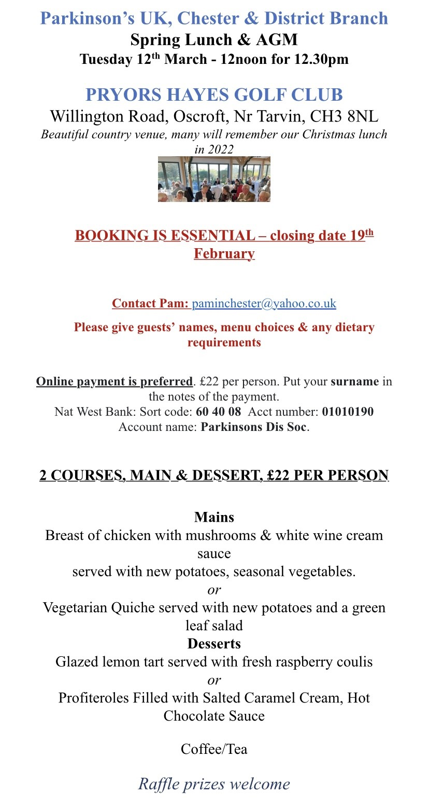

Parkinson’s UK – Chester & District Branch

**Are you or anyone you know affected by Parkinson’s? Would you like to meet others for a chat? You will receive a warm welcome.**

DROP IN CAFÉ

Every 3rd Thursday of each month, 2.30pm – 4pm

Hoole United Reformed Church, Hoole Road, Hoole, Chester, CH2 3NT

*Excellent parking – please note the one-way system*

The United Reformed Church has kindly allowed us to join their monthly event “Cake & Church”, to enable people with Parkinson’s and their family/friends/carers to meet, chat and have tea/coffee and cake in a relaxed atmosphere. There is also a book table – just bring along any you’ve read and take some new ones.

For more information about the above please contact [alistairtranter@btinternet.com](mailto:alistairtranter@btinternet.com)

# **Zoom chat and quizzes**

This takes place on Zoom every Thursday from 5pm and has turned out to be very successful – and great fun!!

# Why not pop in?

**Please contact me if you would like to join in:**

[***paminchester@yahoo.co.uk***](mailto:paminchester@yahoo.co.uk)

**Parkinson’s UK – Chester & District Branch**

**Friday Singing Group**

**St Columba’s Church Hall, Plas Newton Lane, Chester CH2 1PL**

**Fridays 1pm – 2.30pm**

Excellent parking, good access and facilities

Come along, sing your much-loved favourites and learn some new songs too.

Tea, coffee & biscuits - No charge, donations asked for refreshments

Our wonderful group is going from strength to strength with more and more people realising the therapeutic benefits of singing, both physically for the voice/throat/mouth etc and psychologically because it is fun!! Don’t think you have to be a singer or able to read music or have sung in choirs before – just bring yourself and a willingness to have a go.

We look forward to welcoming you.

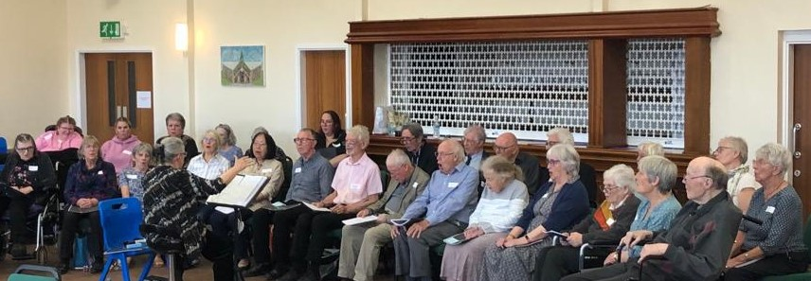

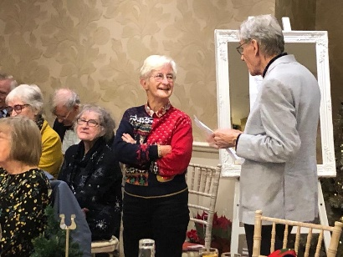*September Songs – entertainment and afternoon tea for our families and friends*

*Christmas lunch at Rowton Hall: Liz decided to retire as the Group’s Secretary, after 10 years. David presented her with a small token of our appreciation for all of her hard work and dedication – amazing job, well done and thanks Liz.*

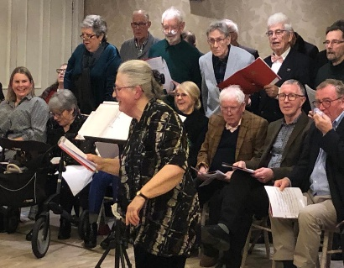*Brenda is an enthusiastic and talented Conductor of our singing group. She obviously has a talent for Christmas Cracker jokes too – well clearly some think so!*

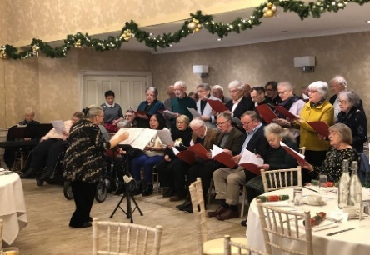A friendly bunch having lots of fun – why not join us?

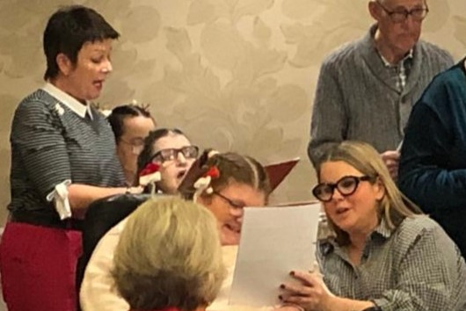

**Chester and District Branch of Parkinson’s UK. Review of 2023.**

2023 has proved to be a pivotal year for the Branch, it has felt to the Committee that we have finally broken away from the clutches of Covid. There has been a full programme of well attended face to face monthly social meetings. New members have steadily been joining the Branch, progress has been made on recruiting new members to the Committee and help is at hand hopefully to resolve our secretarial needs. The use of Zoom has become an integral part of Branch activities. The singing sessions continue to flourish. The campaign to establish a Parkinson’s Nurse for Chester still looks optimistic but in no way certain. The members of the Branch have been surveyed for their views on possible new activities or ideas for 2024.

The need to establish normality this year has once again caused the Committee to put on hold any longer term 3-year plan objectives until 2024

**Singing**

The Branch’s successful Singing Group continues to grow with about 35 members and is much appreciated by all. A very sociable group, it is fun as well as being excellent vocal therapy. We meet every Friday from 1pm to 2.30pm and have an enthusiastic group of volunteers led by our Conductor and 2 pianists.

It is now 2 years since the group restarted (after 18 months of ‘zoom singing’ due to covid) in our new venue at St Columba’s Church Hall, which is perfect for our needs.

On 29th September we held an afternoon of “September Songs” with afternoon tea for our families, friends and Branch members. A lovely time was had by all. It was wonderful to show others that you don’t need to have a great voice or be able to read music in order to enjoy getting together and singing.

**Parkinson’s Post**

The Branch's newsletter, ‘Parkinson’s Post’, continues to be popular with our membership and the wider community. Our Editor, Chris, does an excellent job in producing a very useful and informative document. We print 400 copies, approximately 180 of which are posted to members. The rest are distributed in hospitals, clinics, pharmacies, libraries, churches and at Branch events. It is produced 3 times per year - January/February, May/June and September/October.

Members have been canvassed with the option of receiving it only via email but, apart from a very small number, most wish to receive an actual copy that they can read and refer back to. Although there is an ever increasing cost to the Branch, with postage etc, the Committee consider that it is justified, as it is such a vital part of the Branch’s support for members and an excellent advertisement of our Branch activities.

**Zoom Chat and Quizzes**

This happens every Thursday from 5 - 6 pm and has become a great occasion for folk to share experiences and do quizzes. Not only is it fun, but also has been a source of support and friendship for those in isolation, and we have made new friends in different parts of the country.

**Monthly social events**

Along with our regular haunts, we have visited some new places this year. We arrange a variety of venues for our coffee mornings, lunches and afternoon teas. We also make sure they are in different locations, reflecting our widespread membership. Our annual visit to Arley Hall Gardens (home of our branch president, Viscount Ashbrook) proved especially popular. It has also been encouraging to welcome new members each time and these social occasions make networking possible - another way of supporting each other.

**Drop in Café**

We have continued our relationship with Hoole United Reform Church Chester, to provide a drop in café for our members. It takes place on the third Thursday of each month.

**Contacting our Members**

‘Keeping in Touch’ telephone contacts has continued throughout the year There has been no change....no further volunteers or befriendees taken on. At present we have just 3 volunteers who have been calling their member fairly regularly which has been of benefit and pleasurable for both the member and volunteer. With such minimal numbers there has been no need for a formal supervision or review. It must be over 2 years now that we have been calling our allocated members since our last survey.

**The Committee**

2023 has seen the Committee strengthened by the recruitment of 3 new members. Unfortunately, it also saw the resignation of a long-standing member. The Committee wish to express its thanks and gratitude to Liz McClure for all her efforts but in particular for her outstanding work with the Choir.

One of the new members is currently picking up the responsibilities of the Secretary role with a view hopefully of taking over the position on during 2024. This would solve a long standing requirement.

**Parkinson’s Nurse Project**

The current position is that the Countess of Chester has submitted a business case applying for pump prime funding (2 years funding). The panel will meet and discuss the application this month and we should have an outcome soon.

We are really hopeful that they are awarded the funding, as it will allow a nurse to be recruited and we would work closely with them during the 2 year funding period to help gather the evidence of how valuable a nurse is and support the nurse integrating into the service and community. It is ia major milestone in a campaign that began in July 2018. A huge thank you to the Area Development Manager and all who have contributed and supported the team. We're not quite there yet but closer than we've been before!

**Text Messaging**

The Branch has continued to recruit members for a simple text messaging service, for reminders of events, future dates etc. Currently there are 73 members receiving the service.

**Membership**  
Our current number is 190, which is an increase of 11 from October 2022.  
The 190 excludes the second person of the 10 couples.

**Survey of Members**

The Committee initiated a limited survey of members requesting suggestions and ideas for new activities and changes that could be incorporated into the 2024 programme. The replies raised a number of interesting suggestions some of which will be considered for 2024.

**Neuro Therapy Center (NTC)**

The Branch has had a long standing relationship with the NTC which was recognized and strengthened by the signing of a new ongoing Agreement of Co-operation.

**Financial Arrangements**

Chester Branch finances remain in a healthy position. The Branch continues to emerge from the impact of the Global Pandemic. The effect on income at a local level has been a drop in annual income of around 50%. Branch costs showed similar levels of reduction. As a branch we are seeking to return branch activity to pre-pandemic levels again by initiating the new projects identified within The Branch 2024 Development Strategy.

**The Chester and District Branch Committee, December 2023.**

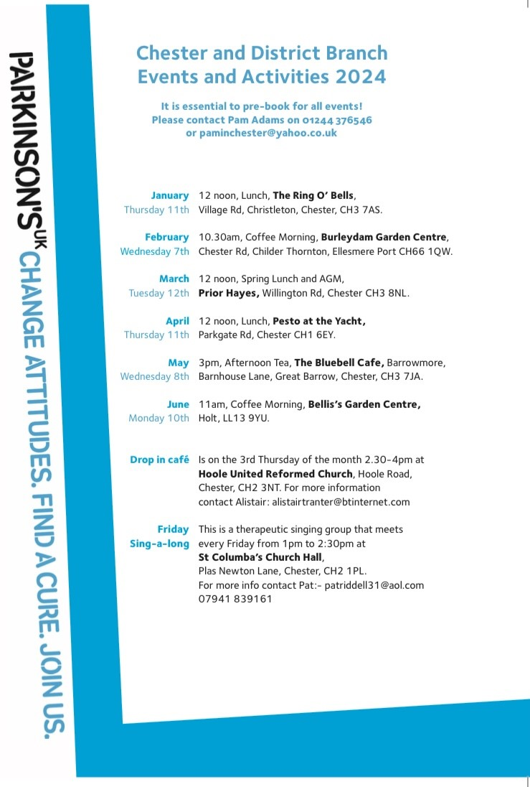

***Damned solicitude***

*Loss of movement, loss of wit*

*That is not the half of it*

*Do not think me brash or rude*

*But spare your damned solicitude*

*“Parkinson’s? That’s awful, right*

*What a dreadful thing to fight.*

*You’re so brave, the way you cope.*

*There’s research, we all must hope*

*In a few years, yes for sure*

*There will be, an end, a cure.”*

*They cock their head and talk so s-l-o-w*

*And very loudly, just as though*

*I’d lost my senses, lost my brain*

*That what’s driving me insane*

*No need to talk as if I’m four*

*Or checked my mind in at the door*

*Whilst I’m all for empathy*

*This really isn’t helping me.*

*Am I slower? Yes, it’s true*

*Lost my edge? Well, so would you*

*Balance iffy? Just a tad*

*But please desist, you’ll drive me mad!*

*I cannot bear your morbid tone*

*If that’s your tack, leave me alone.*

*Constrain your cloying sympathy*

*Do you not get it?*

*I’m still me*

*Gillian Lacey-Solymar*

**2024 Development Strategy Document**

**The Chester and District Branch of Parkinson’s UK**

In 2019, the Chester and District Branch of Parkinson’s UK issued a Development Strategy Document to establish a longer-term initiative for the provision of support and services to all our members. The aim being to establish consistency across annual development plans and ensure that precious local resources are utilised in the most effective and efficient way. This revision of the Strategy Document is both needed and appropriate after the challenging events of the last few years. We make no apologies for the significant similarities between this document and that of 2019 as the overriding strategy remains the same but this document will highlight the specific areas and challenges that the Branch faces in 2024. If we have learnt anything from the last 4 years, it is that the Branch needs to have the attitude and ability to change it’s mode of operation almost immediately, to respond to unforeseen external factors. None more obvious than the Covid Pandemic.

This is a working document which the Branch hope to develop with the help and support of Parkinson’s UK and other local organisations with whom we have developed excellent working relationships. In order to achieve this ambitious objective, it is important to have a sound financial basis which allows planning of projects and support of new initiatives over a number of years. The Financial Summary to support this strategy will be presented as a separate document once this document has been agreed.

**Background**

The Branch has an excellent record for providing opportunities to our members to participate in therapies, social events and presentations concerning important issues. It has campaigned over the years on behalf of its members with local hospital staff over issues such as the ‘Get it on Time’ initiative. It has liaised with GP Practices to ensure new and existing patients can find help on matters relating to Parkinson’s. It is currently involved with Parkinson’s UK and other sectors of the NHS regarding the urgent issue of local Parkinson’s Nurse Support.

The Covid Pandemic had a major impact on the Branch and more importantly our members, as it did across the whole of our society. There were periods when all activities stopped. Gradually some activities commenced on Zoom and then eventually when all of the Committee were in agreement, face to face meetings gradually started to be re-introduced. The effects of the pandemic are still having a significant impact on the operation of the Branch compared to pre-Covid times. Hence the need for the Branch to re-examine what it is presently providing and what it could provide going forward to maximise the benefit to both our current members and those individuals in the area who have been diagnosed with Parkinson’s but aren’t aware of the Branch and what it can offer. While the essence of the 2019 Development Plan remain core to our current aims and objectives for the Branch, there is a need to set new priorities and objectives going forward.

This situation led the Branch to re-examine what it was providing for its members. To look for ways to reach out and help our current members while at the same time attempting to reach individuals diagnosed with Parkinson’s but unaware of our existence. The review identified a number of key areas and services which the Branch will attempt to address over the next 3 years with a series of targeted annual development plans.

**Key Areas**

Provision of a local Parkinson’s Nurse.

Raising awareness of the Branch and it’s activities to the Local Community.

Attempting to increase local fund raising and sponsorship of key Branch activities.

To identify and publicise local therapies.

Social activities and local support.

To share relevant information with our members via our Parkinson’s Post Magazine.

Share experiences and knowledge with other local Branches.

**Development Plan for 2024-2027**

Below is a list of initiatives which are intended to start or continue through 2019 and in many cases beyond.

-To continue working with a range of partners such as PUK Regional and National staff, CWP and Countess of Chester NHS Foundation Trust, NHS West Cheshire CCG, and The Walton Centre to:

* Improve the supply, service and operation of the INNS and Nurse Advice Service.
* Improve our members’ experience when admitted to hospital.
* Improve patient information and knowledge of the pathway and how to access the INNS and PUK Service.
* Contributing to raising awareness of the pathway and referral services with GPs.

-Increasing the provision of activities, therapies and support in conjunction with other agencies and individuals

-Re-establish a Drop in Café in or around Tarporley, ideally based on a similar set up to the Chester Drop-in.

-Increase the branch membership with promotions, awareness activities and improve communications in GP surgeries using modern information systems. Film /TV Loops.-Revisit the feasibility of some type of “outreach” project service to both establish and stay in contact with members who do not/or cannot attend functions.

-Research and identify ways to support people recently diagnosed, younger people and people at work.

-Continue to signpost members to existing regular therapies, organized by the group and others in collaboration with other organisations or individuals.

-Continue to organise a monthly social event where locations are moved around different parts of the district.

- Arrange speakers on related topics, usually 2 or 3 a year.

-Send out News Letter to all members, every 3 months.

-Review our local fund-raising events throughout the year, look for sponsors for key regular activities, ie Parkinson’s Post, Choir and a New Members Promotional Event. Continue making wherever possible an annual contribution to Parkinson’s UK in support of its Research Programmes.

**Summary**

The Committee are well aware that this is an ambitious strategy and programme, but we feel very confident it can deliver based on previous experience. The committee is composed of members with a wide range of skills and experience as well as a high level of commitment. In addition, the committee is pragmatic and therefore if individual activities are unsuccessful or do not deliver as expected we will look to improve and modify the approach for the good of our members, hence the initial description that this is a working, active strategy. We look forward to delivering this strategy over the next few years.

**The Committee**

**Chester and District Branch**

**December 2023**

**2024 Development Plan for Chester and District Parkinson’s Branch**

In line with aims and objective of the of the new revised Branch Development Strategy, the Committee remains committed to the rollout and development of local services and support to our members.

It is the view of the Committee, that while Covid does remain a concern to us all, we are now in a position to approach the role out of activities in manner used pre-Covid. Zoom which has proved to have real advantages in certain areas and hence will remain in the programme.

**Specific Aims for 2024**

1. Continue to support the on-going initiative to establish provision of a local Parkinson’s Nurse for the Chester area.

2. Ensure our members are aware of the most up to date pathways to obtain support from INNS and Parkinson’s UK Nurse Support.

3. Increasing the provision of activities, therapies and support in conjunction with other agencies. Support the introduction of Crown Green Bowling sessions.

4. To re-establish contact with local GP Surgeries to re-introduce leaflets and to examine ways of introducing Parkinson’s to the TV Loop Information systems used in many surgeries.

5. Issue at least 3 editions of the Branch Magazine, Parkinson’s Post to all of our members.

6. Continue to offer our members a monthly social activity, varying both the type and venue each month to meet the different needs of our members.

7. Raise the awareness of the Chester Branch to those living in our area who are directly or indirectly affected by Parkinson’s. This includes the use of monthly local magazines, newspaper articles and the possibility of a local awareness event.

8. Review our local fund-raising events throughout the year, look for sponsors for key regular activities, ie Parkinson’s Post, Singing and a New Members Promotional Event. Continue making an annual contribution to Parkinson’s UK in support of its Research Programme. wherever possible.

9. Continue with the successful weekly singing sessions.

10. Explore ways to reintroduce a Drop in Café in the Tarporley area. Making use of past experience in both Tarporley and Chester to ensure a sustainable solution.

**The Committee**

**Chester and District Branch, November 2023**

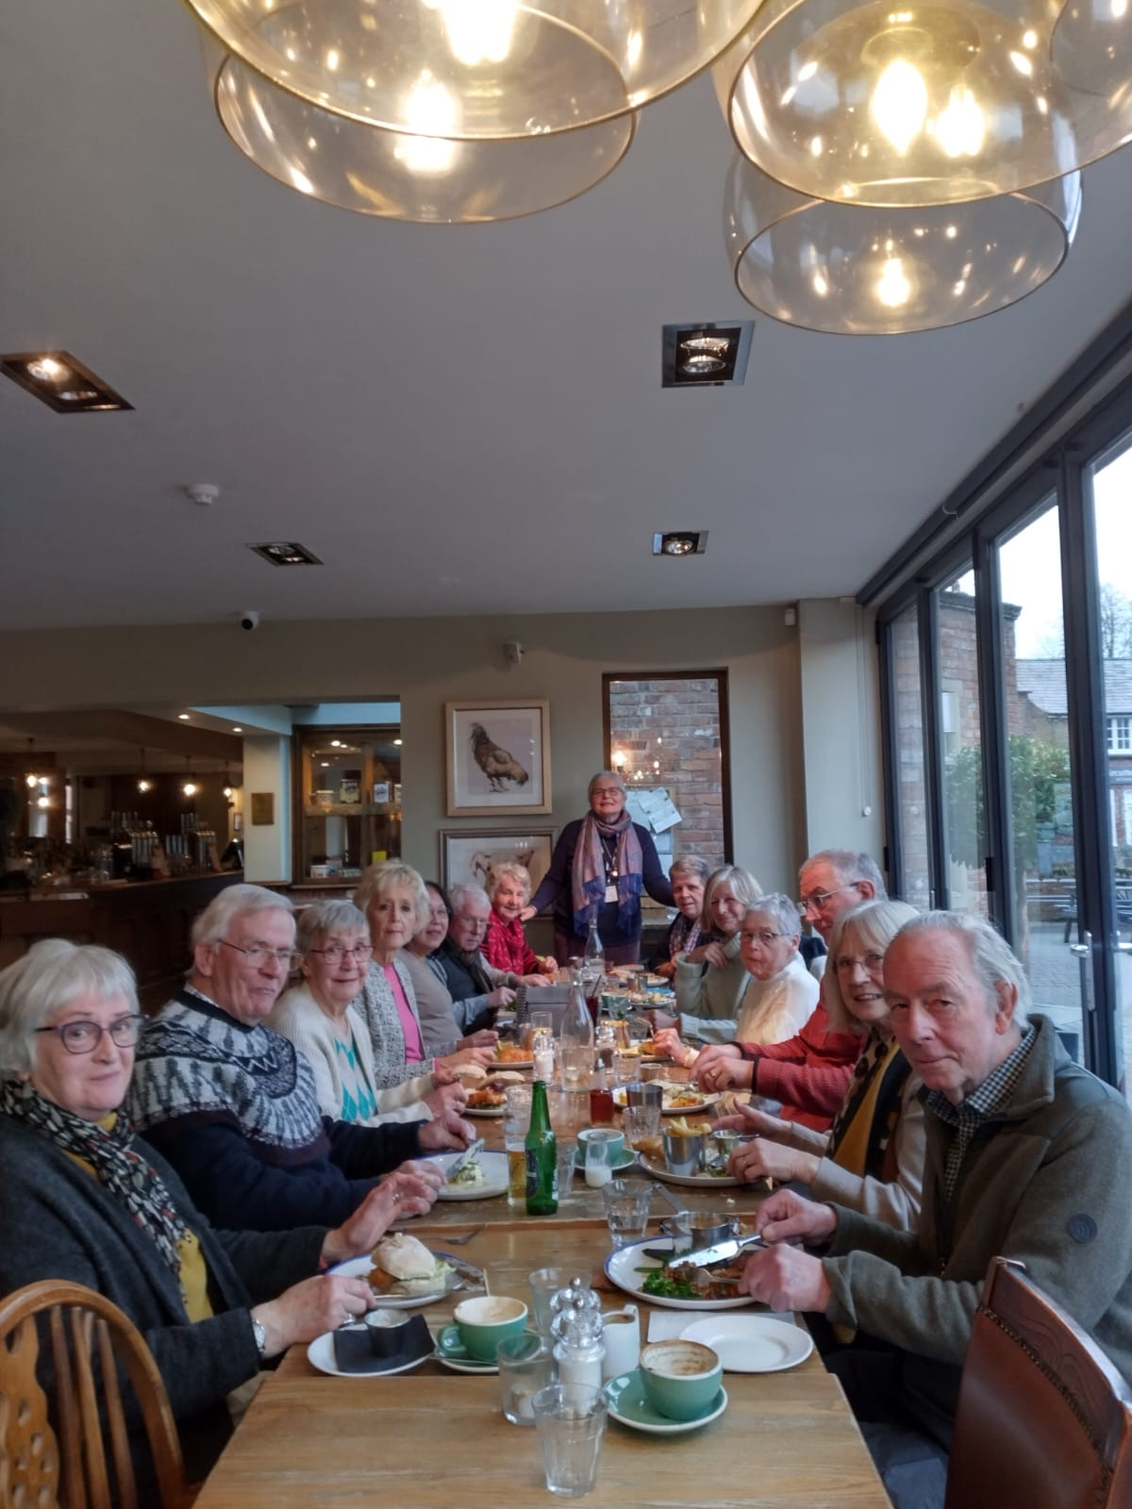

We had a great start to our social programme on 11th January,when we had lunch at the Ring O' Bells in Christleton. The food was almost as good as the company!! It was especially nice to welcome folk who who have only recently joined our group!

**Christmas lunch at Rowton Hall Hotel on 15th December**

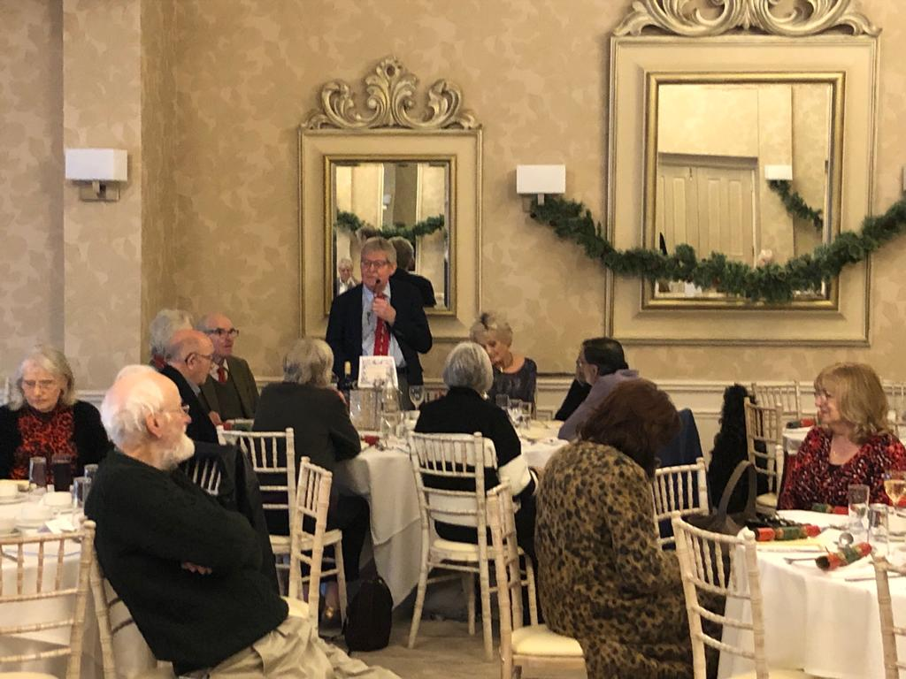

Nick welcomes us and introduces us to Lord and Lady Ashbrook of Arley Hall.

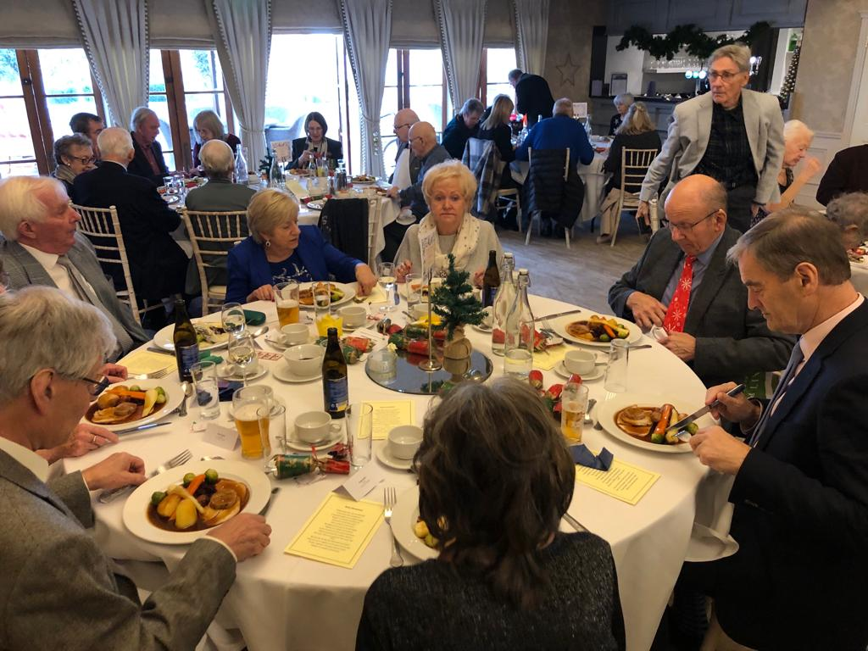  
We had a record attendance of 81.

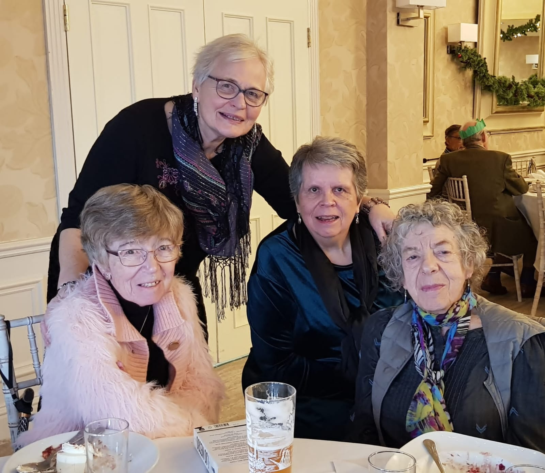

Carolyn (pictured right), from the Stockport Branch joined us.

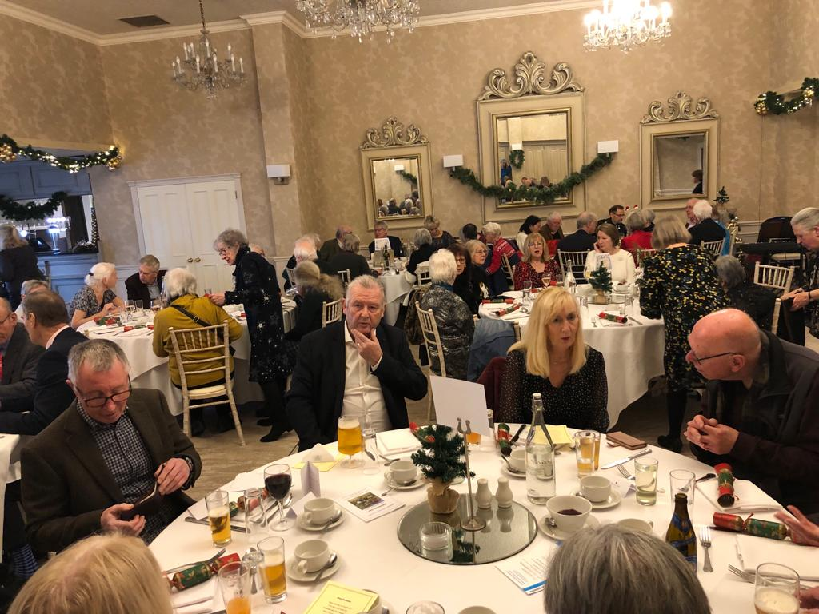

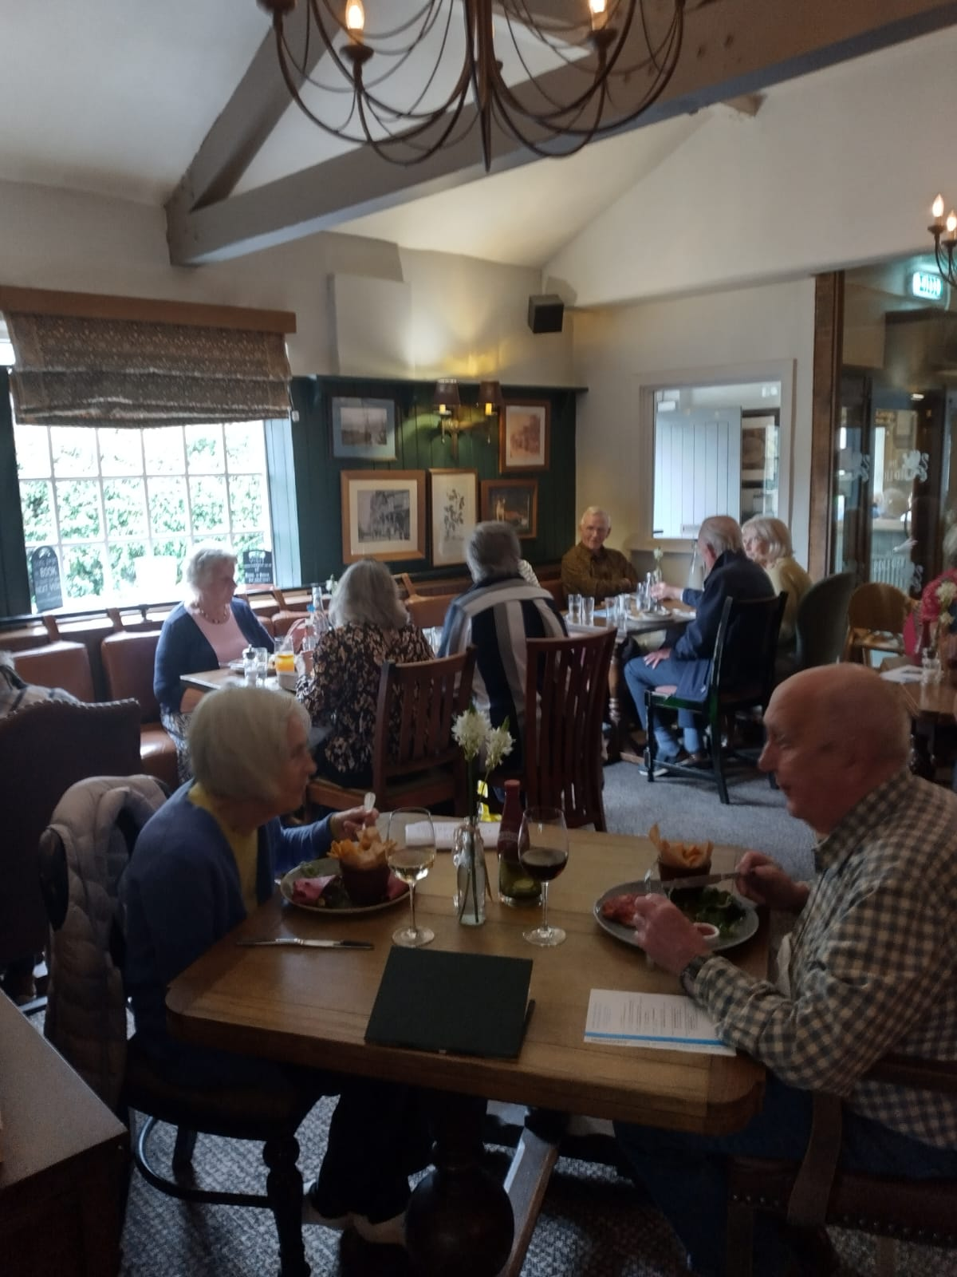

On a lovely autumnal day,a group of us met at the Red Lion in Dodleston for a relaxed lunch together.

_________________________________________________________________________

Please check the events calendar card for all upcoming events. See page 11.

**Multiple Sclerosis Society, West Cheshire – Yoga**



**West Cheshire Yoga, Every Thursday, 11am**

**Thrive, Inside Pro Health Clinic:**

**Greengates, 5 Greenfield Lane, Hoole, Chester, CH2 2PA.**

MS Group members £5 and non members £8

New adapted yoga group, suitable for anyone who would like a slower paced yoga session and relaxation and breathing techniques. Suitable for anyone with MS or a neuro condition, or those able bodied who would like to be more supple and able to keep mobility in good shape.

**Rebecca Pritchard** runs the group. She is an experienced yoga practitioner and a member of the Yoga Alliance. She is also a specialist in breathing and relaxation techniques to help manage anxiety and stress of everyday life. If you want to manage pain, or recovery from a relapse, then Rebecca can advise. The clinic has flat access and is wheelchair accessible, with a disabled access toilet. Parking is right outside.

There is keen interest in this group. There are a maximum of 12 places available. To join, **contact Brenda Brockbank on 07522 384240** for a simple registration form or go along to any session.

**We remember those members of our branch who have died this year**

**Just close your eyes and you will see**

**All the memories you have of me**

**Just sit and relax and you will find**

**I’m really still there inside your mind**



**­­­­­­­­­­­­­­­­­­­­­­____________________________________________________________________________**

I have Parkinson’s

But Parkinson’s

Doesn’t have me!

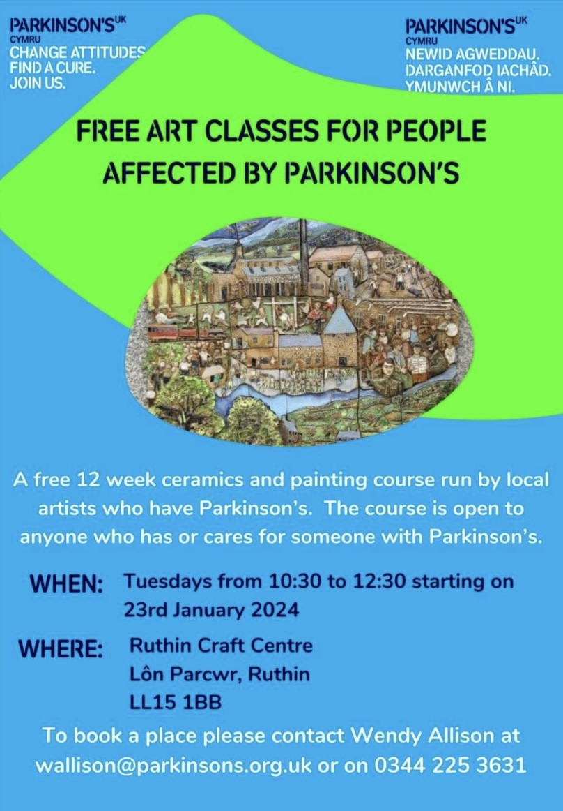

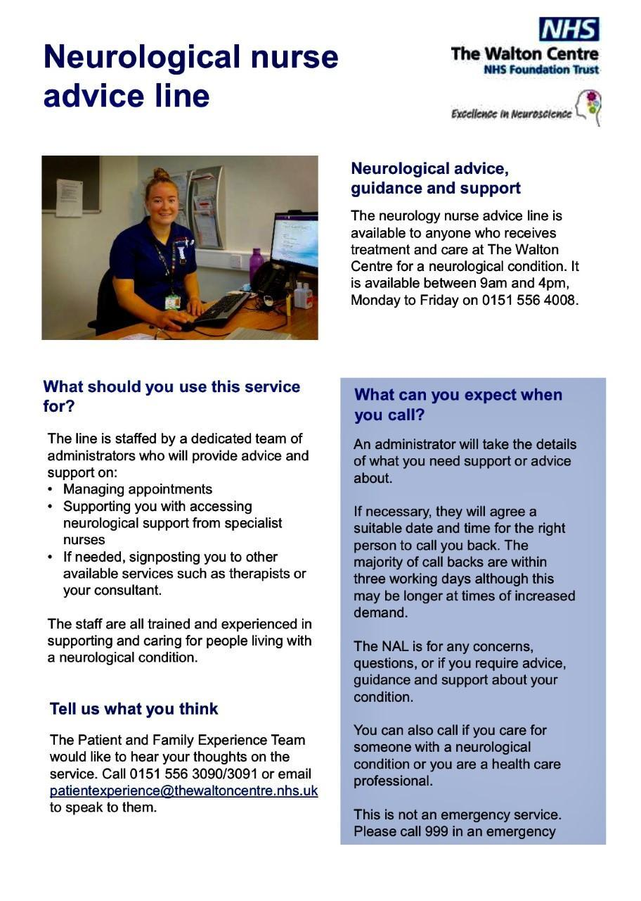

**Do you need help with an application for a Blue Badge, to complete forms for Attendance Allowance, Personal Independence Payment (PIP) or something similar? Parkinson’s local advisers are there to help – just a phone call or email away. You are not alone, contact Rachael Millington or Sara Owen today:** **rmillington@parkinsons.org.uk** **or** **sowen@parkinsons.org.uk**

**Tel: 0808 800 0303**



**Neurotherapy Centre Saltney, Units C1- C4. Brymau Estate 1, River Lane, Saltney, Chester CH4 8RG**

The Centre would love to hear your feedback, please take a couple of minutes to complete their survey about the services and support which would help you. Even if you don't use the Centre currently it would still be really helpful for them to hear your views.

The Survey is available at: https://forms.gle/MFg4p6mv2t4nxvEZ7

**Mental Health Drop-in**  
Every Wednesday between 2.30pm – 3.30pm  
Join Alice for a 1-1 chat in our counselling room to talk through any concerns and experiences you are having, explore opportunities for assistance, and gain information around further support.

|  |  |  |
| --- | --- | --- |
| |  | | --- | | **Access to Exercise & Wellbeing Programme** | |  |

|  |  |
| --- | --- |
| |  | | --- | | Access to Exercise & Wellbeing programme is being led by the team at Neuro Therapy Centre, alongside partners Greenbank Sports Academy in Liverpool, Brio Leisure across Cheshire, and The Walton Centre | |

|  |  |  |
| --- | --- | --- |
| |  |  | | --- | --- | | As part of the programme Brio Leisure have a number of dedicated sessions for people with neurological conditions at their sites across Cheshire and there is a wide range of services offered by Greenbank Sports Academy including an accessible gym and an inclusive sports programme. |  | |

|  |  |  |  |
| --- | --- | --- | --- |
| |  |  |  | | --- | --- | --- | | |  | | --- | |  |  |  | | --- | | **Northwich Memorial Court**  **Chair-based class** - Tuesdays, 12.30pm  Booking not required.  **Brio Northgate Arena, Chester**  **Neuro Gentle Circuit** - Tuesdays 2.15pm **Neuro Gentle Circuit** - Thursdays 2.15pm  Booking not required. | | |

|  |  |  |  |
| --- | --- | --- | --- |
| |  |  |  | | --- | --- | --- | | |  | | --- | |  |  |  | | --- | | **Winsford Brio Leisure**  **Neuro Balance & Strength**  - Mondays 2pm Booking not required. **Aquatherapy** - Tuesdays 10.45am  Offering quieter music and slower movements.  Book by calling 01606 550700 or visit the website. | | |
| |  | | --- | | **Ellesmere Port Sports Village, Brio Leisure**  **Aquatherapy** - Fridays , 11.15am. Booking not required. | |

[**www.neurotherapycentre.org/access-to-exercise-wellbeing**](http://www.neurotherapycentre.org/access-to-exercise-wellbeing)

Chair-based exercise classes, which are free to attend.

· Improve strength and mobility. Safe and gentle exercises

· Designed to reduce risk and promote well-being, mood boosting

· Mental health enhancing, opportunities to meet new people

All sessions are free to access. To book or for more details, contact info@healthboxcic.com or telephone: 0151 355 0205





­­­­­­­­­­­­­­­­­­__________________________________________________

Parkinson’s UK have information about exercise, please see the link to the exercise hub below

<https://www.parkinsons.org.uk/professionals/exercise-hub>

**Branch Fundraising**

In our post-covid world, all charities are facing difficulties with fundraising, as if it wasn’t difficult enough already!

But fundraising doesn’t have to be huge or complicated and anyone can do it. For example, when life started to return to “normal” in May 2022, St Clare’s Church in the Lache, Chester resumed having coffee after their Sunday morning service. Each Sunday it is for a different cause and one Sunday a month it is for Parkinson’s. After 20 months they have raised a staggering £879.16

So not a difficult task, but very beneficial financially as well as promoting Parkinson’s in the community, win win.

Any ideas how you might get involved? From little acorns. . . . .

**Donations.**

The branch always welcomes donations or even more appreciated would be a regular standing order donation...if anyone would like to make a donation whether it be regular or one off please get in touch with Ron Welsh, our treasurer, who will supply the bank information for you to arrange the donation/standing order. You can also contact any of the committee.

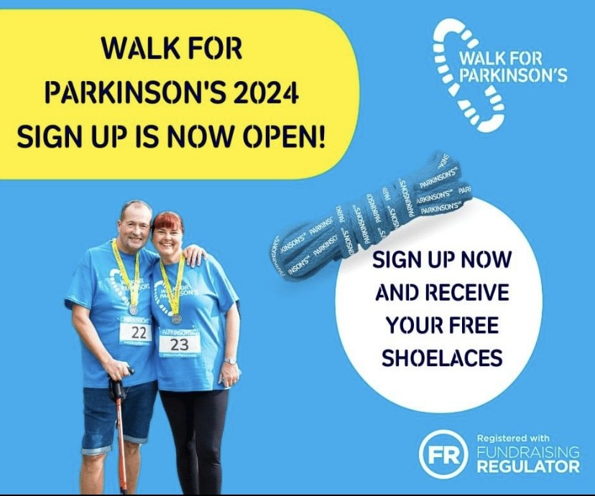

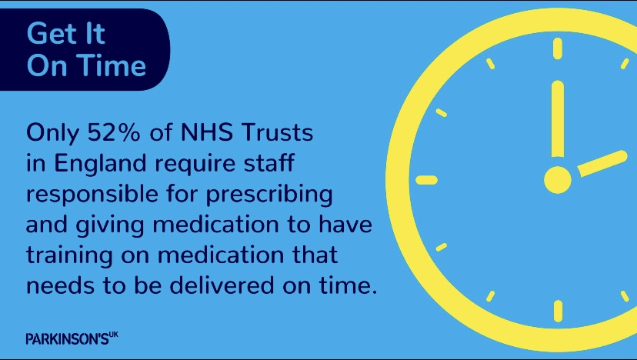

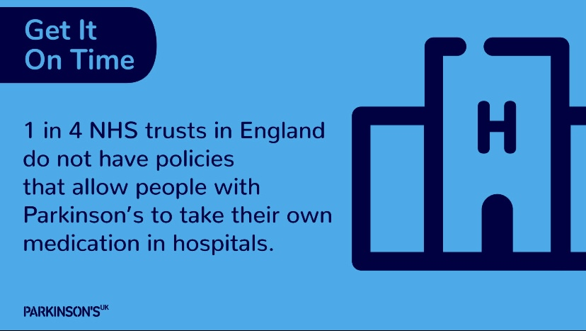

**BRANCH TEXT MESSAGING SERVICE.**

The Branch have a Text Message reminder service sending out reminders of upcoming events to our members free of charge. If you would like to receive this service, then you just need to take a few minutes to register.

Just text your NAME, MOBILE PHONE NUMBER and YES to 07768146835. If you would prefer us to send the text messages to a friend, family member or carer on your behalf then just add FOR and the NAME to your text message request to join. If you believe you have already registered but haven’t been receiving any messages could you, please resubmit your details to the above number and in addition to the requested information just include PROBLEM

—---------------------------------------------------------------------------------------------

**Other Contacts**

For information and resources from Parkinson's UK visit [www.parkinsons.org.uk](http://www.parkinsons.org.uk)

For advice, emotional support or to access the Parkinson's Adviser service, contact the Parkinson’s UK Helpline, available Monday to Friday: 9am to 6pm, Saturday: 10am to 2pm on **0808 800 0303** or by emailing [hello@parkinsons.org.uk](mailto:hello@parkinsons.org.uk)

The Walton Centre Nurse Advice Line is 0151 556 4008

Branch Membership – If you know anyone who has Parkinson’s or is caring for someone with Parkinson’s or would just like to join, please encourage them to get in touch with any of the committee, thanks.



**Get involved in research**

Find out how you can get involved in research and help us power breakthroughs.

Parkinson's research needs everyone. People with and without Parkinson's, of every age, gender and ethnicity. Without volunteers, progress in Parkinson’s research would be impossible.

Taking part in a research study can come in many forms, from questionnaires to trialling new treatments. Some research can be done from home, while other opportunities will involve visiting a hospital or research centre.

Whatever you're ready for, you can make a difference. Join the network today to:

* get connected to research and the scientist carrying it out
* take part in clinical trials and studies
* have your say on what research is needed and how it's done.

If you have any questions, get in touch at [rsn@parkinsons.org.uk](mailto:rsn@parkinsons.org.uk) or call 020 7963 9398.

<https://www.parkinsons.org.uk/research/get-involved-research>



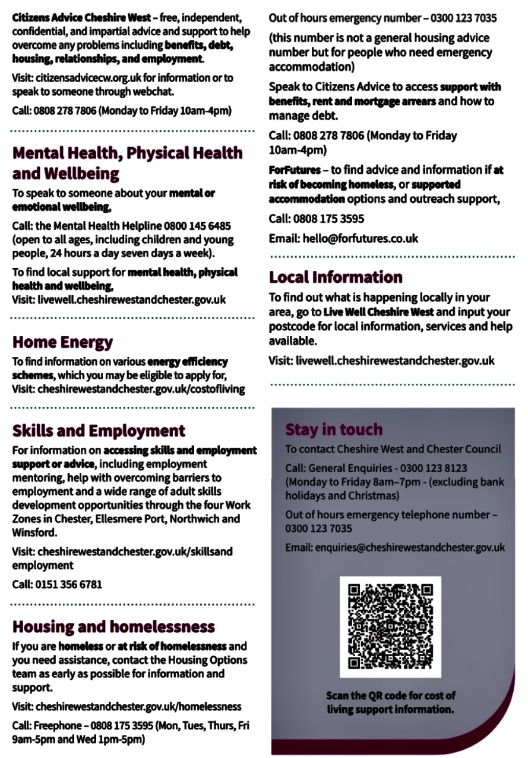

**Contacts.**

**Chairman Vice Chair &**

Nick Dent **Singing group contact**

01244 301378 Pat Riddell

[npdent@aol.com](mailto:npdent@aol.com) 07941839161

[patriddell31@aol.com](mailto:patriddell31@aol.com)

**Secretary Membership**

Alistair Tranter Margaret Whaley

01244 311402 [mkwhaley3@gmail.com](mailto:mkwhaley3@gmail.com)

[alistairtranter@btinternet.com](mailto:alistairtranter@btinternet.com)

**Social Secretary Treasurer**

Pam Adams Ron Welsh

01244 376546 [ronwelshco@aol.com](mailto:ronwelshco@aol.com)

[paminchester@yahoo.co.uk](mailto:paminchester@yahoo.co.uk)

**Parkinson’s Post** John Fetherston

Chris Knight [fetherston132@gmail.com](mailto:fetherston132@gmail.com)

[chrisknight1@hotmail.co.uk](mailto:chrisknight1@hotmail.co.uk)

Phil NuttallAlan Needham

[phil60011@btinternet.com](mailto:phil60011@btinternet.com) [alan.needham52@gmail.com](mailto:alan.needham52@gmail.com)

David Stoddart

[david.stoddart3@btinternet.com](mailto:david.stoddart3@btinternet.com)

Viscount Michael Ashbrook – President of the branch.

Chester & District Branch Parkinson's UK

c/o The Bluecoat Charity,  
The Bluecoat,  
Upper Northgate Street,  
Chester  
CH1 4EE