PARKINSON'S POST.

Chester & District Branch.

February 2023
Facebook: Parkinson’s UK – Chester District Branch
Twitter: @Parkinson’s Chester
Website: chesterparkinsons.weebly.com
Contents.

2. Contents
3. Spring Lunch / AGM
4. Pat’s Notes
5. AGM - Committee nominations
6 - 8. Movers Shakers. Therapeutic singing group
9. Drop in Café, Chester
10. Neurological Advice Line (English)
11. Neurological Advice Line (Welsh)
12. Neuro Therapy Centre
13. Parkinson’s UK
14 - 16. Pam’s Pictures
17. Exercise Opportunities
18. Pam’s Zoom chat
19. Tennis / Exercise Hub / Donations
20. Parkinson’s Exercise Group (Healthbox)
21. Poem
22. Keeping in Contact / Text Message Service
23. Events Summary
24. Other contacts / Morton Roberts
25. In memory
26 - 27. Cheshire West & Chester Support info (https://chesterva.org.uk/wp-content/uploads/2022/12/7220-double-side-A4-flyer-digital.pdf
28. Contacts

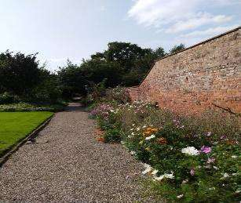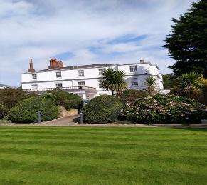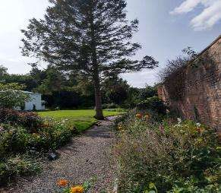
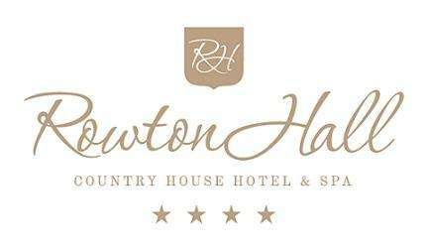
Rowton Hall hotel, Rowton Lane, Whitchurch Road, Chester CH3 6AD
Parkinson’s UK, Chester & District Branch
Spring Lunch & AGM
Monday 6th March, 12noon for 12.30pm, in the Ballroom
£26 per person for 3 courses & coffee/tea
Online payment preferred: “Parkinson’s Dis Soc”, Sort code: 60-40-08, Acct no: 01010190
State names with payment
Then please email your menu choices to: paminchester@yahoo.co.uk
Bookings must be received by Monday 20th February
MENU
Cream of Parsley and Potato Soup Potato Croutons, Parsley Oil
Baked Carbonara Pasta Frittata Three Tomato Salad, Pesto Flavours
****
Pan Roasted Breast of Chicken Dauphinois Potatoes, Green Garden Vegetables, Coriander and Lime Jus
Wild Mushroom Gnocchi Truffle oil, Curly Kale, Parmesan
****
Dark Chocolate Mousse White Chocolate Mousse, Milk Chocolate Sauce Anglaise
Strawberry and Elderflower Panacotta Mixed Berry Soup
****
Tea & Coffee
*******
Please pay online if possible or call or email Pam: Tel: 01244 376546. Email paminchester@yahoo.co.uk
Pat’s Notes
As I said in the previous Parkinson’s Post in November, I am currently the ‘Acting Chairperson’ whilst our Chairman Nick is poorly. Nick had his operation on 13th January and the recovery time may be a few months. Get well soon Nick, we look forward to welcoming you back.
What a year we have had since our AGM in April 2022! After a tentative start we are ‘back to normal’ – except there is no going back and we have a ‘new normal' as some things have changed. Our committee meetings have continued on zoom as we find it so convenient, a positive remnant of Covid. Our social gatherings have been well thought out by our Social Secretary Pam and the venues chosen have felt safe and accessible. Our drop-in at United Reform Church Hall in Hoole, the Thursday zoom chat and our Friday singing session are continuing to grow and are proving to be very much appreciated by all. We also had a lovely day at Arley Hall Gardens, thanks to the hospitality of our President, Viscount Ashbrook.
At our hugely successful Christmas lunch at Pryors Hayes golf club, I spoke about our wonderful volunteers. I used our Treasurer, Ron, with over 25 years service, as an example of what volunteers are prepared to do, quietly, without fuss, for the benefit of others. We have been extremely fortunate this year in recruiting three new volunteers – Margaret is now our Membership Secretary and John and Alan joined in January and are keen to get involved where they can. Thank you to all three and welcome. Unfortunately, Mel Stevens has decided to stand down from the committee after several years of service and we wish to thank Mel for all she has done for the Branch, she will be greatly missed. So, we still need more help, if you want to join us please get in touch, we would love to hear from you.
The Spring Lunch and AGM is once again at Rowton Hall (see details on previous page) on Monday 6th March. We are lucky to have such a venue, the staff are very welcoming and the atmosphere is very relaxed. We hope to see you there.
Pat Riddell (Acting Chairperson)

Chester and District Branch Parkinson’s UK 2022
President - Viscount Ashbrook of Arley.
The membership of the branch committee for 2022 was as follows:
Nick Dent - Chair.
Pat Riddell - Vice Chair.
Ron Welsh - Treasurer.
Alistair Tranter - Secretary.
David Stoddart - Membership Secretary.
Pam Adams - Social Secretary.
Liz McClure - Choir
Mel Stevens - Keeping in Touch (KIT) Project.
Margaret Whaley Co-opted
John Fetherston Co-opted
Alan Needham Co-opted
With the exception of Mel Stevens, all of the above are available for re-election. It is recommended that, with the exception of Mel Stevens, all of the above named be elected to the committee for 2023.
AGM Mon: 6th March 2023 - Election of Honorary Officers for 2023.
It is usual at the AGM to elect the Chair, Vice Chair, Secretary and Treasurer. It is left to the Committee to appoint such officers as they think fit.
Recommended that the following be elected as Honorary Officers for ensuing year:
Chair - Nick Dent
Vice Chair - Pat Riddell
Treasurer - Ron Welsh
Secretary - Alistair Tranter
The formal, confirmatory, elections will take place at the next face to face event, our AGM on 6th March with a Parkinson’s UK staff member present.
Parkinson’s UK – Chester & District Branch
“Movers Shakers”
Therapeutic singing group
St Columba’s Church Hall, Plas Newton Lane
Chester CH2 1PL
Fridays 1pm – 2.30pm
Excellent parking, good access and facilities
Come along and sing your much loved favourites and learn some exciting new pieces
Tea, coffee & biscuits
EVERYONE WELCOME
(with or without Parkinson’s)
BRING A FRIEND
No charge, donation asked for refreshments.
Email contact: elizabeth.mcclure070@gmail.com
Telephone Liz: 01244 409414

Movers Shakers

This incredible “choir” has now been going over 10 years. We have rehearsed at the neurotherapy Centre, on zoom during the pandemic, and are now going from strength to strength at St Columba’s Hall, Plas Newton Lane, initially chosen for its spacious size and convenience of parking.
Little did we know we would be renting it at a very generous rate and its acoustics turned out to be very good!
Although it has been awarded grants and had performance in cathedrals, it is unfair to consider it a normal choir. It has many of the functions of a normal choir, but it is especially directed to help the muscles of speech and swallowing which can be problematic in those with neurological disease. As for the social support and networking that goes on at break time, let alone the consumption of cake and biscuits – it is something to be wondered at!!
Our wonderful tripartite team of leaders has new ideas and exercises for us all the time – who knows what we will be up to next, but do come along and join us at St Columba’s. If you do require support from a carer, please bring them with you.
Our first mini performance since lockdown was carolling at the Christmas party at Pryors Hayes, and we subsequently sang more carols at the drop in centre at the URC in Hoole – a good beginning, and we gained excellent feedback from both, as well as enjoying doing them.
We look forward to seeing you!
Liz McClure, January 2023

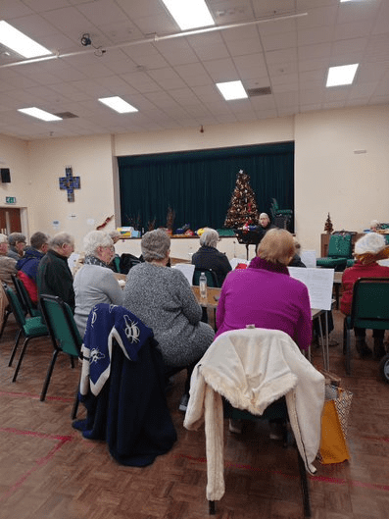
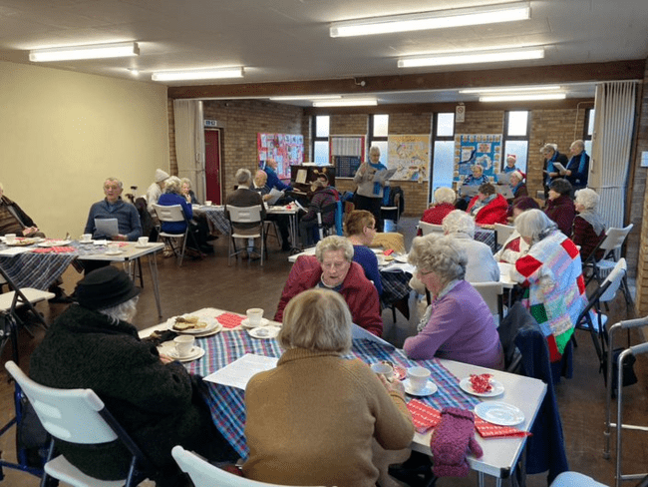
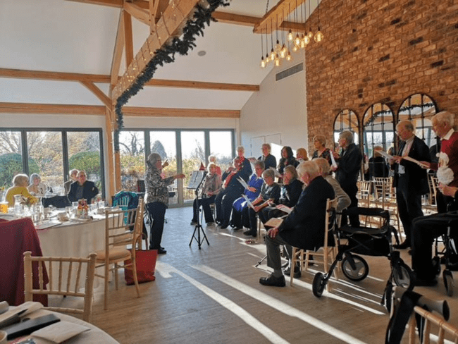
Parkinson’s UK – Chester & District Branch
Are you or anyone you know affected by Parkinson’s? Would you like to meet others for a chat? You will receive a warm welcome.

DROP IN CAFÉ

Every 3rd Thursday of each month.
2.30pm – 4pm
Hoole United Reformed Church,
Hoole Road, Hoole,
Chester, CH2 3NT

Excellent parking – please note the one-way system
The United Reformed Church has kindly allowed us to join their monthly event “Cake & Church”, to enable people with Parkinson’s and their family/friends/carers to meet, chat and have tea/coffee and cake in a relaxed atmosphere. There is also a book table – just bring along any you’ve read and take some new ones.
For more information about the above please contact

alistairtranter@btinternet.com
Our Website: http://chesterparkinsons.weebly.com/
We are on Facebook: https://www.facebook.com/ParkinsonsCh/

Need advice about your Parkinson’s? Call the Parkinson’s UK Helpline 0808 800 0303
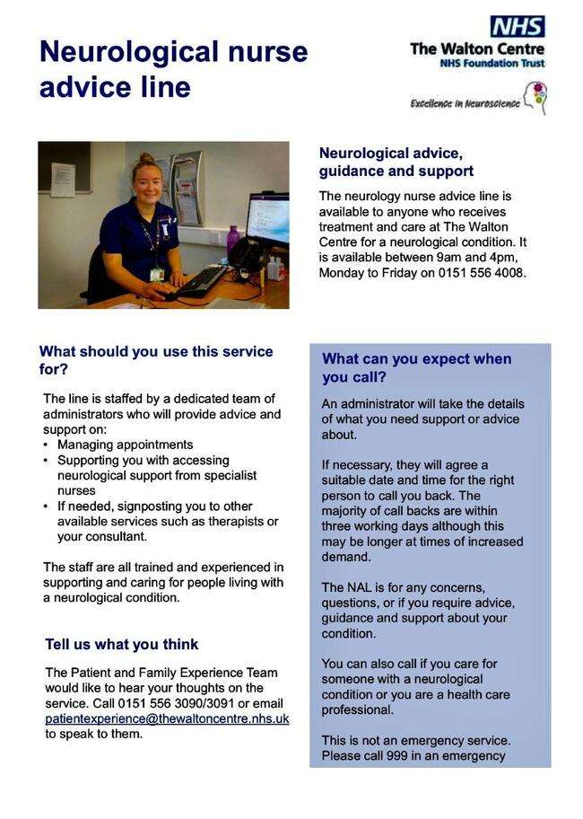

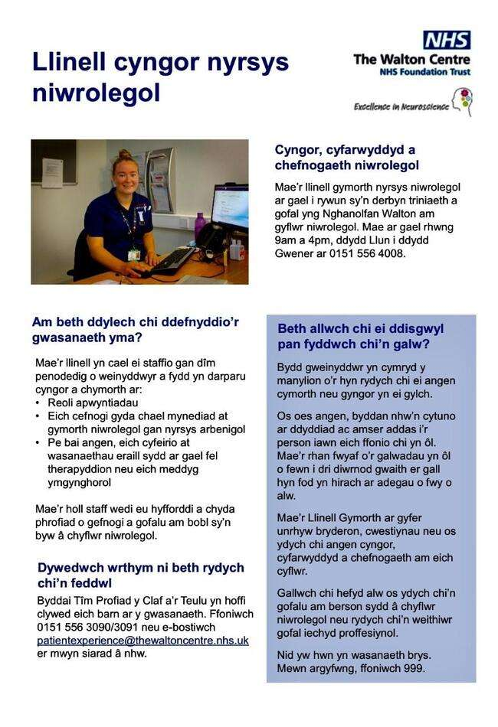

Happy New Year - from all at the Neuro Therapy Centre
The Neuro Therapy Centre provides practical support and therapies to help manage the symptoms of a wide range of long term neurological conditions including MS, Parkinson's, MND and ME. The Centre supports nearly 500 people across North Wales, Cheshire and Wirral
We are at: C1- C4. Brymau Estate 1, River Lane, Saltney, Chester CH4 8RG
2022 was a busy year for the Neuro Therapy Centre and we want to say a big thank you for all your support, donations and fundraising during the year. We have a number of developments planned during the year ahead, including extending opening hours to enable us to increase access to our services, introducing new therapies and facilities, and extending our Access to Exercise project for a further three years. We hope you will continue to share the journey with us this year
- 459 group exercise sessions were held alongside numerous 1-1 physiotherapy sessions and gym sessions.
- 400 live online group exercise sessions were held over Zoom.
- Our recorded sessions were viewed 948 times.
- 97 support groups were held as well as a weekly mindfulness and relaxation session.
- The number of people we support has increased and we've welcomed 138 new people to our services.
- We held our first Business Lunch helping to share the impact of our work and show our importance in the region.
- We've received more than a thousand online donations and many more donations through our collection boxes, at the Centre, and through our events.
- Our Golf Day and Fashion Show returned - raising a total of £6,500 to support the Centre.
- Our Big Give Christmas Challenge raised over £16,450
- We were a nominated charity for the Chester Business Club Charity Ball which raised £15,000 to support our services.
- Thanks to people ticking the gift-aid box when donating we've been able to claim nearly £5,500 in gift-aid - ticking that box really does make a difference!
- Our Access to Exercise project has helped train fitness instructors from across the UK with the knowledge they need to start supporting people with neurological conditions - taking our impact national. Our online conference even attracted attendees from across the globe to hear about the project.
The Centre is open: Monday 9.00am - 7pm,Tuesday, Wednesday and Thursday 9.00am – 4.00pm, Friday 9.00am – 2:00pm
To arrange a tour of the Centre please call 01244 678619 to make an appointment. https://www.neurotherapycentre.org/

Parkinson's UK is here to provide information and support to anyone affected by the condition.

Our helpline is a free, confidential service. Trained Advisers, including Parkinson's Nurse Advisers, Benefit and Employment Advisers and a Care Adviser, provide information about all aspects of living with the condition, including:
- medical issues, including symptoms and treatments
- emotional support
- health and social care
- local activities
- employment and benefits
- signposting to other sources of information
Helpline Advisers can put you in touch with a Parkinson's Adviser in your local area if more local or in depth information and support is needed.

Parkinson's Local Advisers have a wide range of knowledge and expertise about Parkinson’s and can help if someone:
- has been newly diagnosed and is looking for advice and information
- is looking for tips on how to deal with the day to day impact of Parkinson's
- would like to find out about services in their local area, including health services, such as Parkinson's Nurse Specialists and Physiotherapy and how to access them
- has a friend or family member who needs support
- needs emotional support
- wants to learn about their rights and entitlements
- needs help navigating the benefits process
- needs support with anything else relating to life with Parkinson's
The free helpline is open:
Monday to Friday - 9 am-6pm
Saturday - 10 am-2 pm
Please call: 0808 800 0303

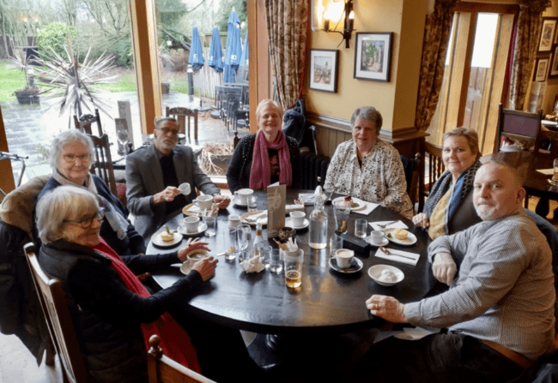
Lunch at Pesto.

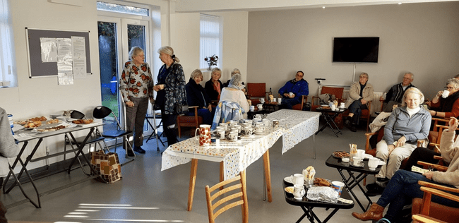
Coffee morning at St Clare’s church Chester.

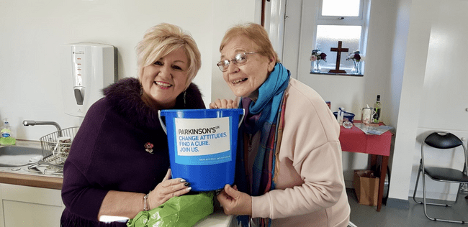
Coffee with a smile at St Clare’s.

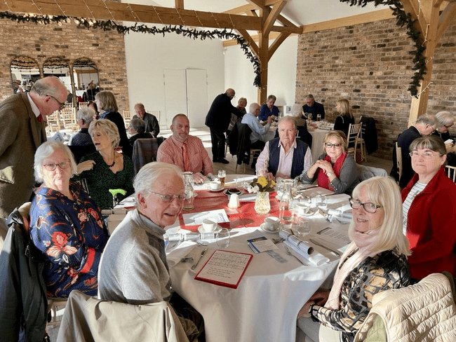
Christmas lunch, Pryors Hayes Golf Club.

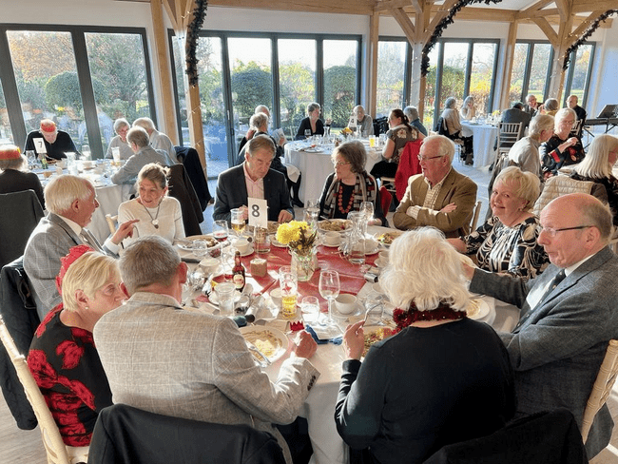
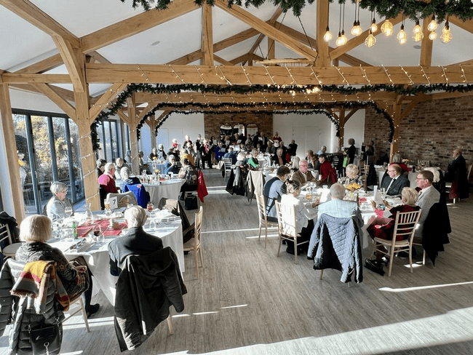
Christmas lunch, Pryors Hayes Golf Club.
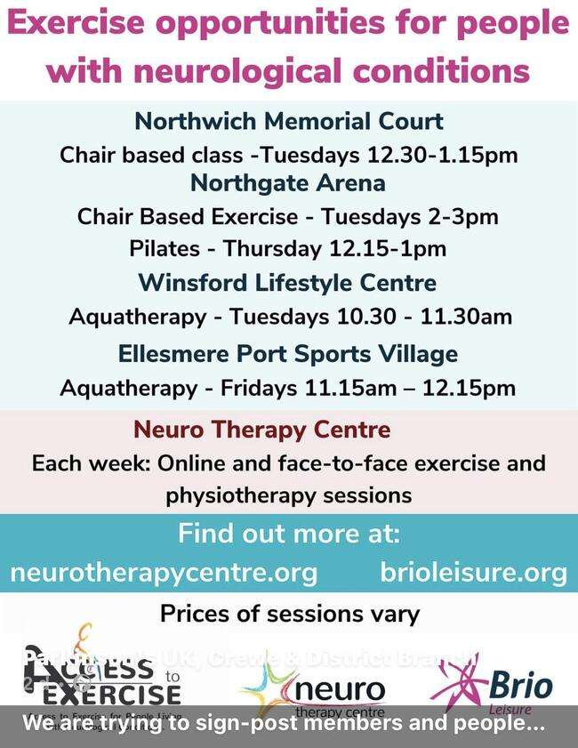

Zoom chat and quizzes
This takes place on Zoom every Thursday from 5pm and has turned out to be very successful – and great fun!!

Why not pop in???
Please contact me if you would like to join in:

paminchester@yahoo.co.uk

__________________________________________________________________________________

Parkinson’s UK have information about exercise, please see the link to the exercise hub below

https://www.parkinsons.org.uk/professionals/exercise-hub

_________________________________________________________

Donations.

The branch always welcomes donations or even more appreciated would be a regular standing order donation...if anyone would like to make a donation whether it be regular or one off please get in touch with Ron Welsh, our treasurer, who will supply the bank information for you to arrange the donation/standing order. You can also contact any of the committee.

What is support? What does it mean?
It’s providing a prop, a shoulder to lean.

It’s empathy, a nod, knowledge, a clue,
Someone to care, who will listen to you.

It’s a laugh, or a cry, a dilemma, a joke,
Support surrounds you, scorn will never poke.

Support is everything. Never being alone.
Reassurance tenfold, your warm comfort zone.

No question is wrong, so pull up a chair.
Others speak up, your troubles they’ll share.

Support is caring and sharing, it’s lending an ear.
Empathising and hearing, as things become clear.

Support makes it better. Troubles you can park.
Better out in the open, than alone in the dark.

Please come and join any of our activities at
Chester & District Parkinson’s UK

IMPORTANT - KEEPING IN CONTACT
If there is one thing which we have all learnt during the Covid pandemic, it is the importance of keeping in contact with family and friends.
That ability to maintain contact is something which the Branch Committee feel is vital at any time, but even more so today, as it tries to provide up to date information and support to our members.
The Parkinson’s Post enables us to reach all our members and we have increased the number of issues during the pandemic. However, it is not suitable for those events which occur in between publications.
When we need to inform members quickly, we use e-mail, text messaging and Facebook, so it would therefore be helpful to have as many email addresses and mobile telephone numbers as possible.
Our records suggest that we only hold email and mobile numbers for about 50% of our members. We would like to see that number increase.
If you haven’t provided your email or mobile phone number and you would like to receive notification of new events and information, then please contact me at npdent@aol.com with your contact details.
Many thanks, Nick Dent.
BRANCH TEXT MESSAGING SERVICE.

The Branch have a Text Message reminder service sending out reminders of upcoming events to our members free of charge. If you would like to receive this service, then you just need to take a few minutes to register.

Just text your NAME, MOBILE PHONE NUMBER and YES to 07768146835. If you would prefer us to send the text messages to a friend, family member or carer on your behalf then just add FOR and the NAME to your text message request to join. If you believe you have already registered but haven’t been receiving any messages could you, please resubmit your details to the above number and in addition to the requested information just include PROBLEM

In summary (Events)

Monday 3 - 4pm Choir. on Zoom. Contact Alison Richards 07899 726859 or thecommunitysingingcompany@gmail.com More information in the link below.
https://localsupport.parkinsons.org.uk/activity/online-social-singalong
https://www.facebook.com/search/top?q=the%20community%20singing%20company

Thursday 5pm Pam’s People – Zoom chat every week, contact Pam for joining details. Also see the link below
https://localsupport.parkinsons.org.uk/activity/chester-branch-zoom

3rd Thursday of each month 2.30 -4pm - Drop in Cafe at Hoole United Reformed Church. For Details contact Alistair on 01244 311402

Friday 1 - 2.30pm Therapeutic singing group – Every Friday at St Columba’s, contact Liz for details.

April - Tuesday 25th. Coffee Morning, Okells Garden Centre, Nr Tarporley CW6 0EP.

May - Monday 22nd. Coffee morning followed by a tour of the gardens. Arley Hall Gardens, Arley, Northwich CW9 6NA.

June - Thursday 22nd. Lunch, Bellis’s Garden Centre Holt LL13 9YU.

It is essential to book for the above coffee mornings or Lunch
Contact Pam: 01244 376546 or paminchester@yahoo.co.uk

Free IT Support at Home see link below.
https://abilitynet.org.uk/at-home/request-free-it-support-home

Other Contacts

For information and resources from Parkinson's UK visit www.parkinsons.org.uk

For advice, emotional support or to access the Parkinson's Adviser service, contact the Parkinson’s UK Helpline, available Monday to Friday: 9am to 6pm, Saturday: 10am to 2pm on 0808 800 0303 or by emailing hello@parkinsons.org.uk

The Walton Centre Nurse Advice Line is 0151 556 4008

Branch Membership – If you know anyone who has Parkinson’s or is caring for someone with Parkinson’s or would just like to join, please encourage them to get in touch with any of the committee, thanks.

__________________________________________________

Further to the article in the last Parkinson’s Post, page 26, you can see an update in the link below about the success of Morton’s exhibition.

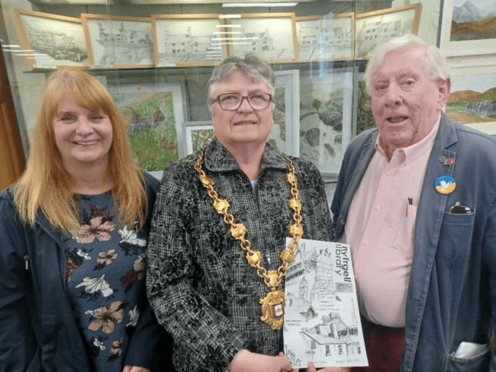

https://www.denbighshirefreepress.co.uk/news/23142291.amazing-happens-aisle-three-ruthin-tesco/?fbclid=IwAR2AoNDza-Fnhsp88yuHeEzfQLEEeomhmgVciAz08YD6XXiguBecTN6VxlI

We remember those members of our branch who have died this year

Just close your eyes and you will see

All the memories you have of me

Just sit and relax and you will find

I’m really still there inside your mind

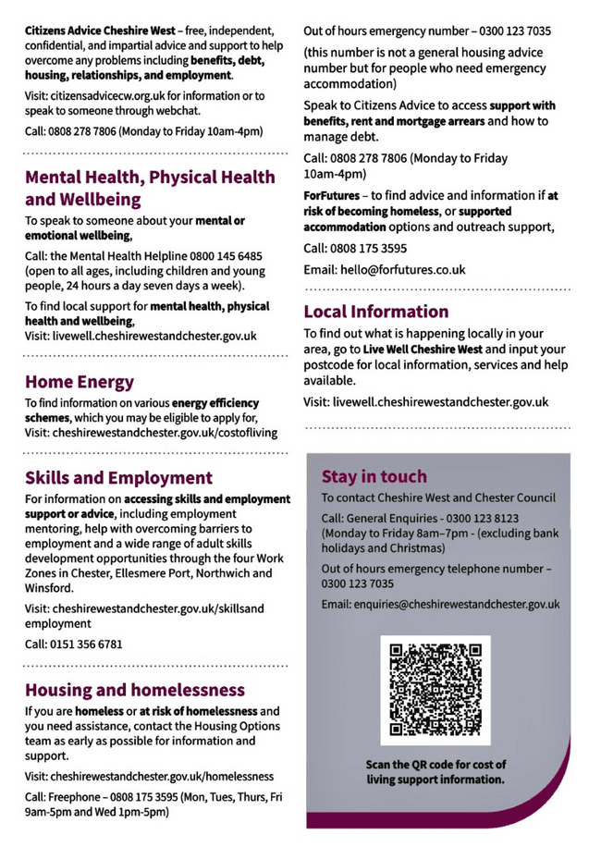Contacts.

Chairman Vice Chair
Nick Dent Pat Riddell
01244 301378 07941839161
patriddell31@aol.com

Secretary Membership
Alistair Tranter Margaret Whaley
01244 311402 mkwhaley3@gmail.com

Social Secretary Choir
Pam Adams Liz McClure
01244 376546 01244 409414

Treasurer Parkinson’s Post
Ron Welsh Chris Knight
07771633621 chrisknight1@hotmail.co.uk

﻿Chester & District Branch Parkinson's UK
c/o The Bluecoat Charity,
The Bluecoat,
Upper Northgate Street,
Chester
CH1 4EE

