PARKINSON'S POST

Chester & District Branch
October 2023
Facebook: Parkinson’s UK – Chester District Branch
Twitter: @Parkinson’s
Chester Website: chesterparkinsons.weebly.com
Contents.
1. Pictures of Arley Hall, home of our President Viscount Ashbrook
2. Contents
3. Nick’s Notes
4. Drop in Café, Chester / Pam’s Zoom chat
5-6. Landlines
6. Fundraising
7. Neurological Advice Line (English)
8. Neurological Advice Line (Welsh)
9. Poem / Pam’s Pictures
10-11. Pam’s Pictures
12. Visit to Arley Hall
13. Parkinson’s UK
14-17. Therapeutic singing group
18. Christmas Lunch 2023
19-20. Walk for Parkinson’s Marbury
21. Exercise Opportunities
22. NTC information
23. Parkinson’s in the Park, Upton / Donations
24. Introduction to Healthbox
25. Healthbox virtual exercise group
26. Text Message Service / Other contact
27. London Underground Poster
28. Events Summary
29-30. Cheshire West & Chester Support info https://chesterva.org.uk/wp-content/uploads/2022/12/7220-double-side-A4-flyer-digital.pdf
31. Live Loud
32. Contacts
Nick’s Notes

I must say it does seem a little strange sitting down to write the Chair’s Notes having had several months “on vacation”’ enjoying reading Pat’s most interesting and witty contributions. On a more serious note, I would like to extend my thank you for all the good wishes I have received while I have been off.
That’s enough of that, lets get back to more interesting matters. It does feel as if the Branch is generally back where it was pre-pandemic, but in a strange way feeling better and stronger. There has been a steady increase in new members, which is always welcome, although we do need to look at ways of making the Branch’s existence more visible in the community. The choir is going from strength to strength. I took the opportunity recently to attend a session of the choir and I must say I was very impressed with all aspects of the organization, I cannot recommend it strongly enough.
The monthly social events are once again being well attended and after many appeals we are finally seeing new faces on the Committee, not that there isn’t room for you if you were thinking of getting involved.
I would like to thank those members who sent in responses to our survey for suggestions and ideas for new activities. The Committee are currently preparing a revised Branch Development Strategy for the next few years and your replies will certainly help us finalise some of the detail. We hope to share this with you in the next edition of the Parkinson’s Post.
Finally, I must say a sincere thank you to my fellow Committee members and particularly to Pat. I was fortunate and you are fortunate that we have such a dedicated and committed team of people looking out for our best interests.

Nick Dent

Parkinson’s UK – Chester & District Branch

Are you or anyone you know affected by Parkinson’s? Would you like to meet others for a chat? You will receive a warm welcome.

DROP IN CAFÉ

Every 3rd Thursday of each month, 2.30pm – 4pm

Hoole United Reformed Church, Hoole Road, Hoole, Chester, CH2 3NT

Excellent parking – please note the one-way system

The United Reformed Church has kindly allowed us to join their monthly event “Cake & Church”, to enable people with Parkinson’s and their family/friends/carers to meet, chat and have tea/coffee and cake in a relaxed atmosphere. There is also a book table – just bring along any you’ve read and take some new ones.

For more information about the above please contact alistairtranter@btinternet.com

Zoom chat and quizzes
This takes place on Zoom every Thursday from 5pm and has turned out to be very successful – and great fun!!

Why not pop in?
Please contact me if you would like to join in:
paminchester@yahoo.co.uk

Landline telephones are going digital - are you ready?

The technology we currently use to make landline phone calls is due to be upgraded by December 2025. Landline phone calls have traditionally been delivered over the old telephone network which is known as the Public Switched Telephone Network (PSTN). BT has decided to retire the PSTN by December 2025, and other landline providers plan to follow a similar timescale. This means that in the future, landline calls will be delivered by digital technology, which uses a broadband internet connection.
BT’s timeline for the changeover is:
- Summer of 2023 onwards – East Midlands, Yorkshire & Humber, Northern Ireland
- Autumn of 2023 onwards – North West and London
- Winter of 2023 onwards – West Midlands and South East
- Spring of 2024 onwards – Wales, East Anglia, North East
- Summer of 2024 onwards – Scotland and South West

If you have a landline phone, your landline provider will contact you to let you know when the process to migrate from your old landline to your new telephone service will apply to you. BT has set up a special service to help make the transition easier for clients who are unsure about the process, or worried about making the switch. This service can also support more vulnerable clients, or those with additional needs (for example, those who use a telecare alarm system.) You can talk through your specific circumstances and get support from BT by calling 0800 800 150.

Why is it happening?
The equipment used in the PSTN was developed and installed in the UK in the 1980s, and is becoming harder and more expensive to maintain. At the same time, telecoms providers are investing in new systems and networks such as full-fibre technology.
So, broadband and phone companies have decided to switch off the old network and deliver landline calls over new digital technology to make sure that our phone services continue into the future. Your landline provider will contact you to let you know when the process to migrate from your old landline to your new telephone service will apply to you.

What do I need to do?

You don’t need to do anything until your provider tells you your telephone service is changing, or until you decide to change your telephone service.
Once a home phone service is moved from PSTN to VoIP, the phone will generally work in the same way as it always has, but it will need to be plugged into a broadband router instead of into the phone socket on your wall. If you need any new equipment - for example, a new router – or if you need a new broadband service installed, your provider should arrange this. It’s important you talk to your provider about how the service will work for you.
This change will affect other devices that rely on a phone line, such as some fire and burglar alarm systems and telecare devices. So, you should mention those devices to your provider and check if these need to be replaced or reconfigured to continue working.

Do I have to have broadband to get the new landline service?
Once the PSTN is switched off, customers who wish to continue having a landline phone, and do not already have broadband, will generally need to have a suitable connection – this is the case even if they don’t use a broadband service. We expect that providers will have a range of options for people in this situation, so customers should not be forced to take out a high-speed broadband package if they do not want to.

Will VoIP phones work in a power cut?
Unlike traditional phones, a phone connected to a broadband router will not work in a power cut, as the router gets its power from the mains.
If you rely on your landline - for example, you don’t have a mobile phone, you’re unable to use a mobile phone or you don’t have mobile signal inside your home - your provider must make sure you are able to contact the emergency services during a power cut. This could be in the form of battery back-up so your landline will continue to work, or giving you a basic mobile phone to use in this situation.
___________________________________________________________________

Branch Fundraising

As you are aware, the branch stopped all our face to face fundraising in March 2020 due to a little thing that happened back then. We’re now looking to start up again, to boost the ‘coffers’, which will enable us to maintain all the events etc and hopefully do more.
In the past we did a lot of fundraising and awareness days at local supermarkets but this does take a huge amount of effort and we would need quite a few people prepared to give their time to stand and shake a bucket. So we’re looking for any ideas you might have to raise funds. Please contact any of the committee and fingers crossed we can put some events in place later this year.
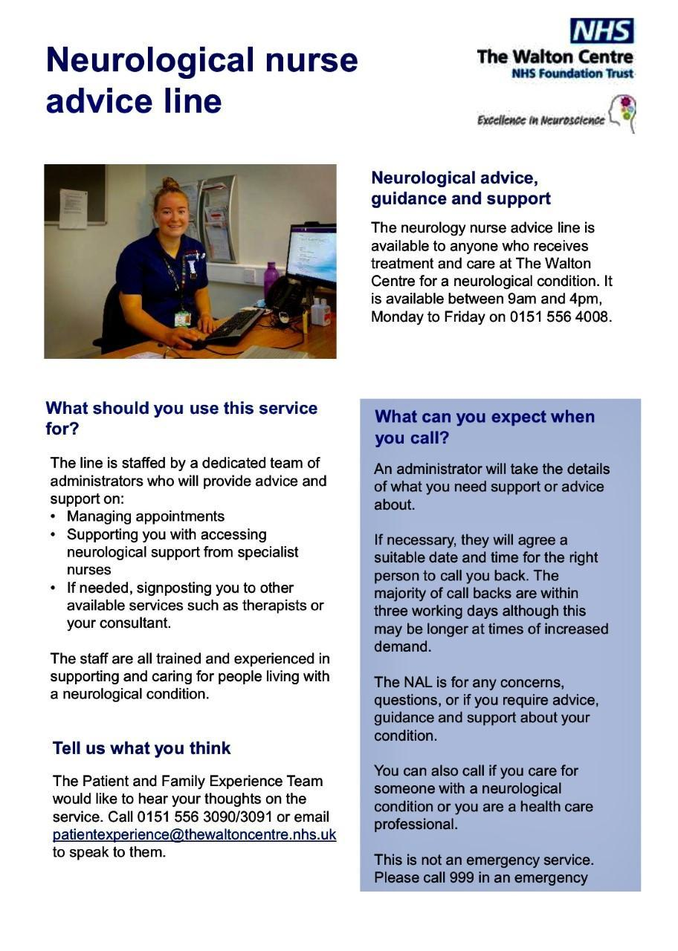

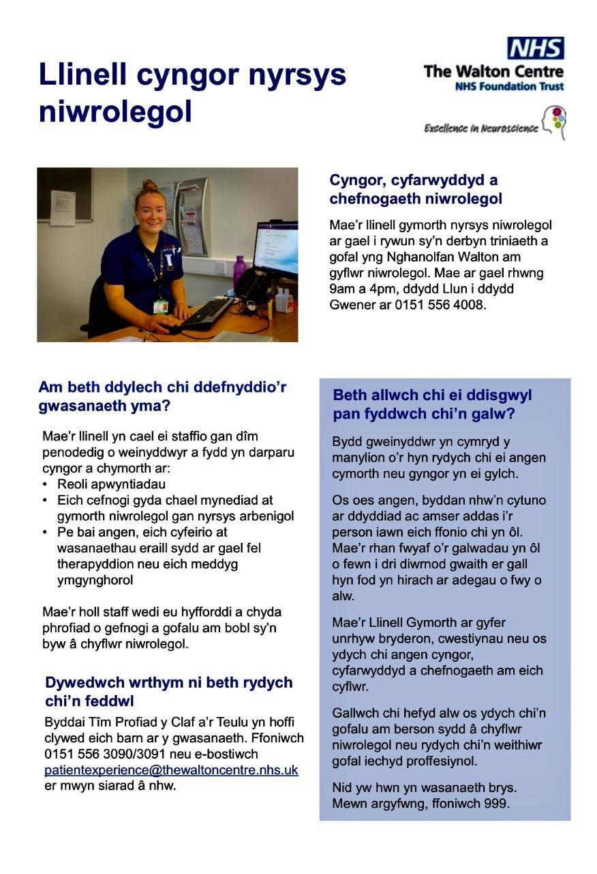

WHAT IF?

What if we’re never ready?
What if, this is as close to being ready that we’ll ever be?
What if, the biggest regret we have when we look back on life,
is that we wasted time waiting, for what?
What if, the last thought we have when life comes to an end,
is that we didn’t do enough living?
This is it.
This is life, right here, right now.
Today is the day.
Life waits for no one.
Seize the moment, seize the day.
Dance like nobody’s watching.
Watch the sunset.
Eat the delicious cake.
Walk barefoot on the cool grass.
Be alive.
Put a hand on your chest
and feel the heartbeat
pulsing through your body And live!
__________________________________________________

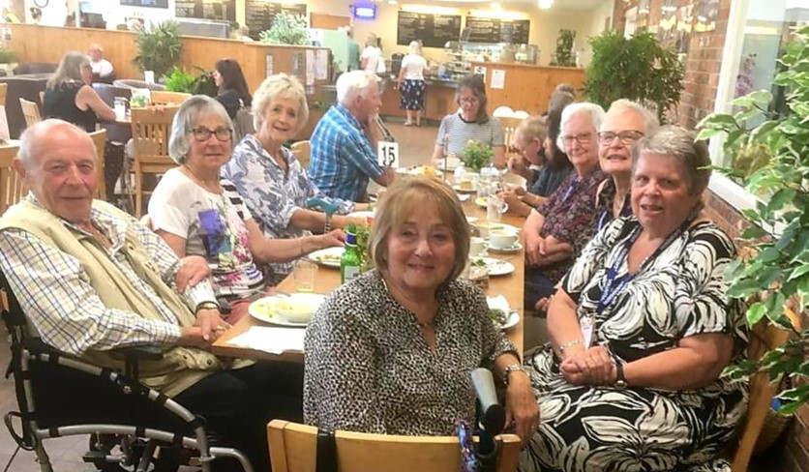
Lunch at Bellis’s in June

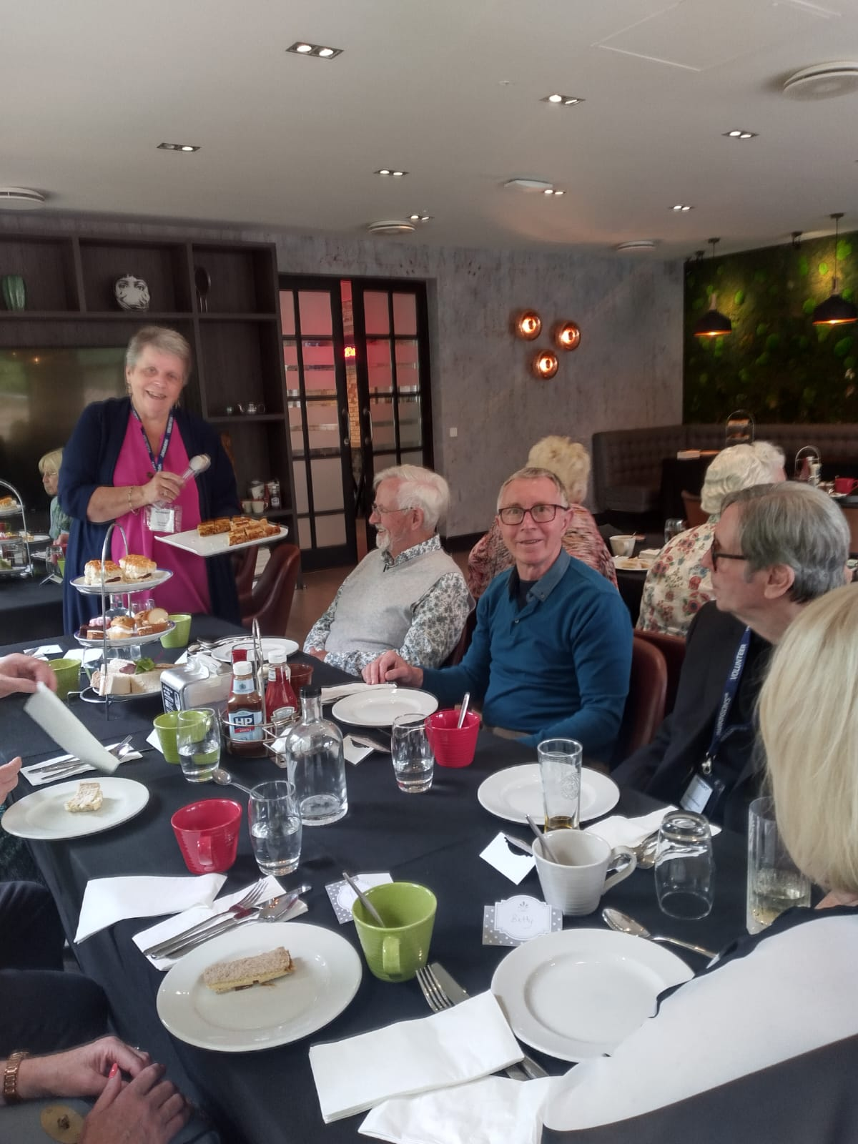
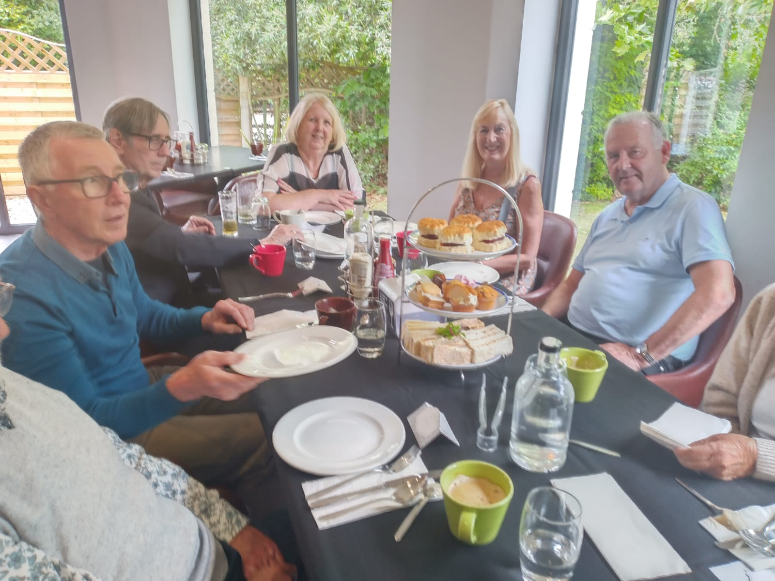
Afternoon tea at St David’s Hotel in July
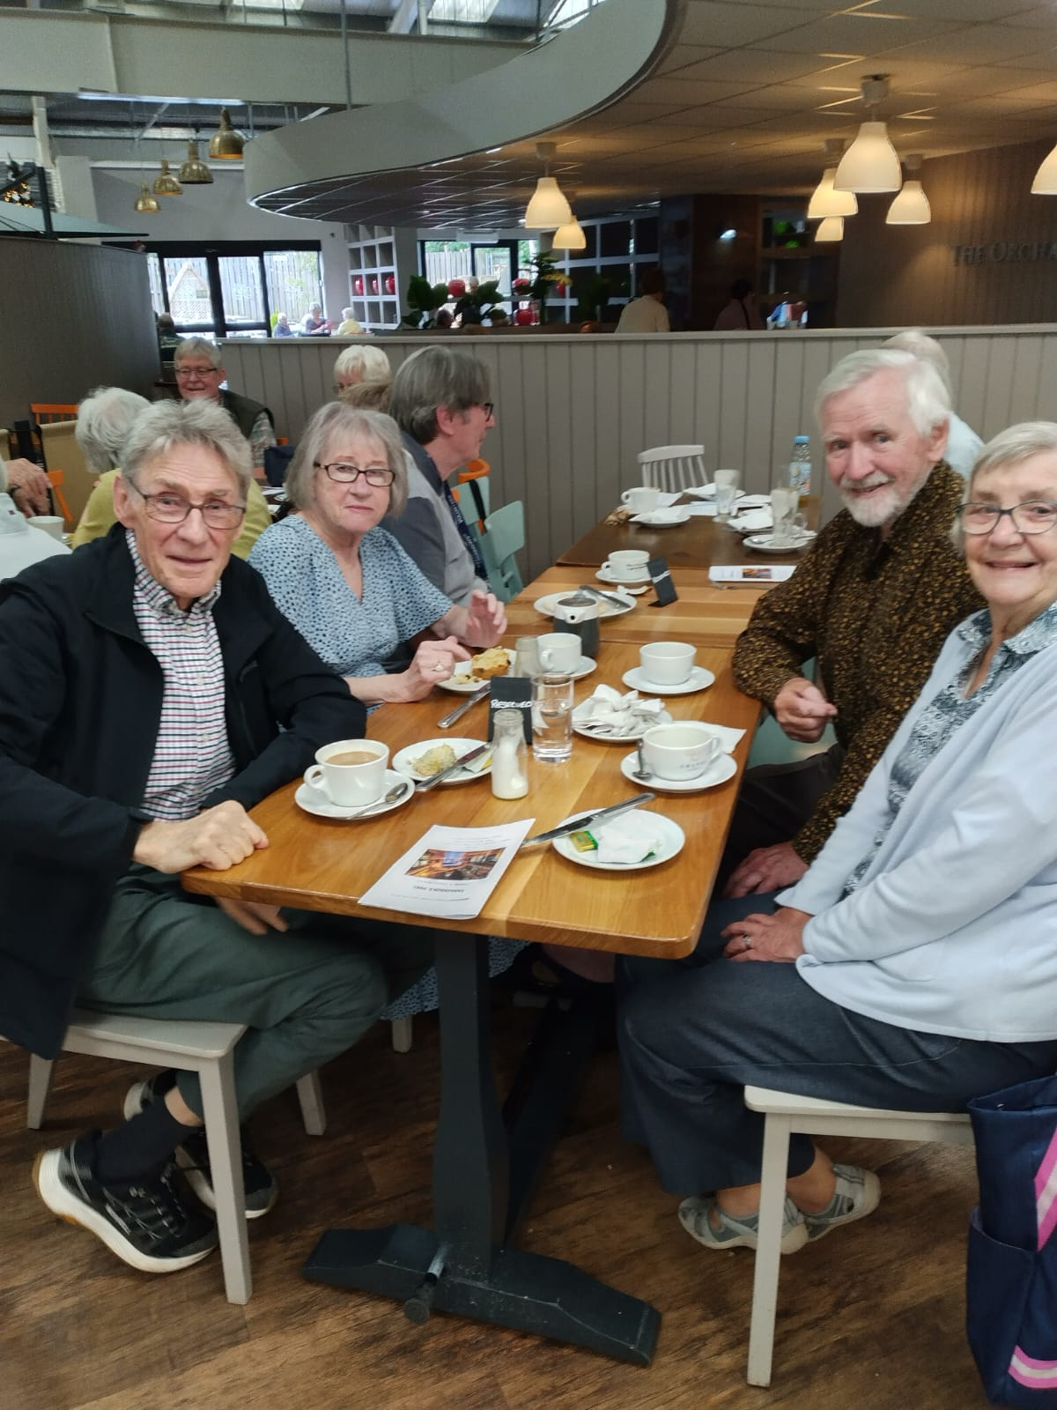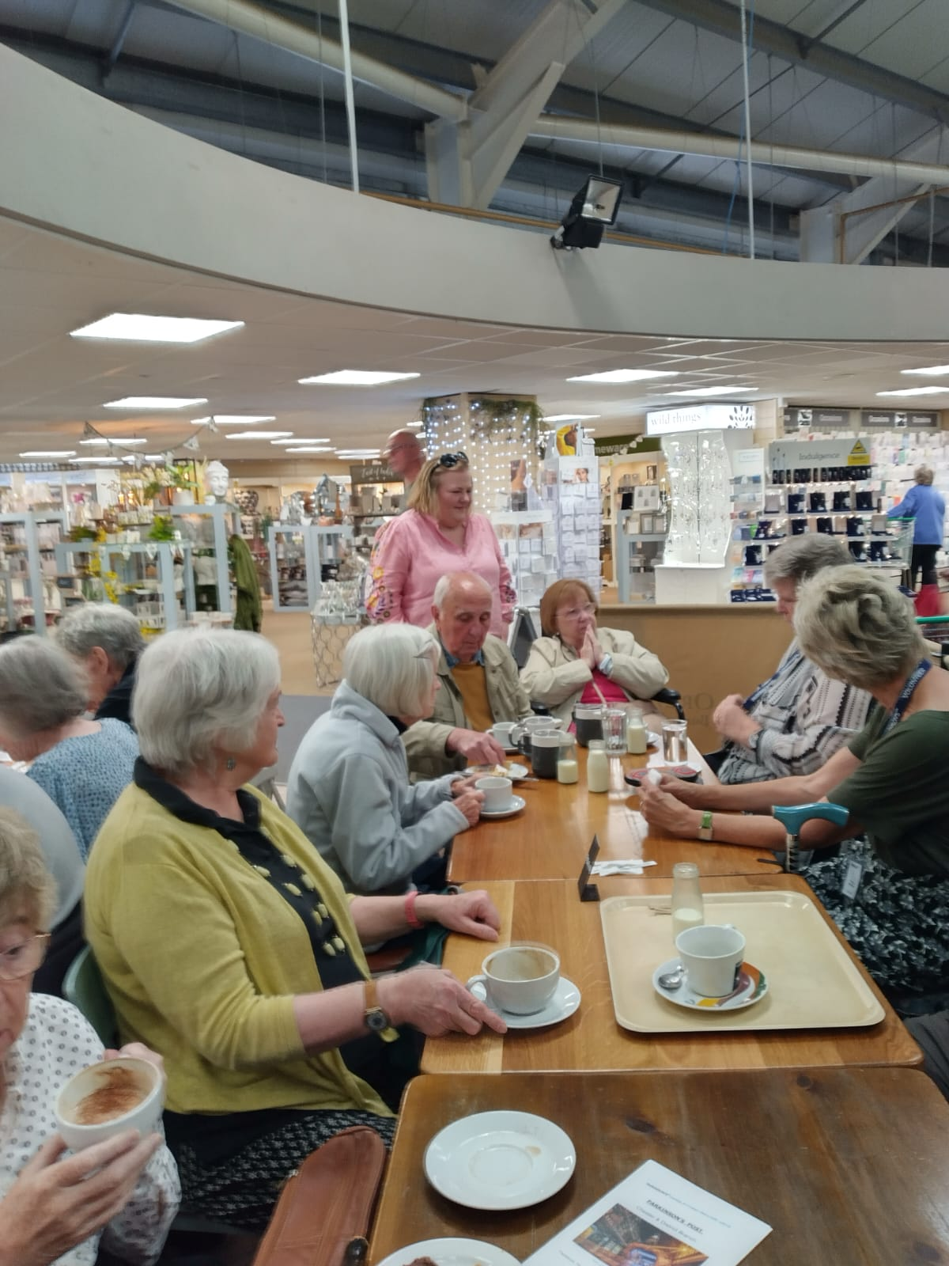
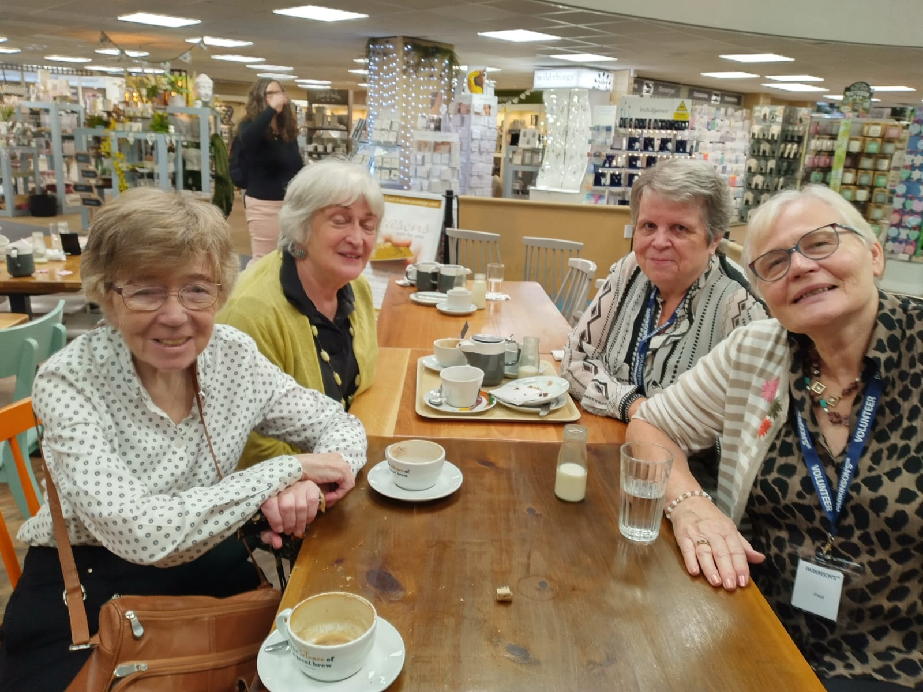
Burleydam coffee morning

Visit to Arley Hall
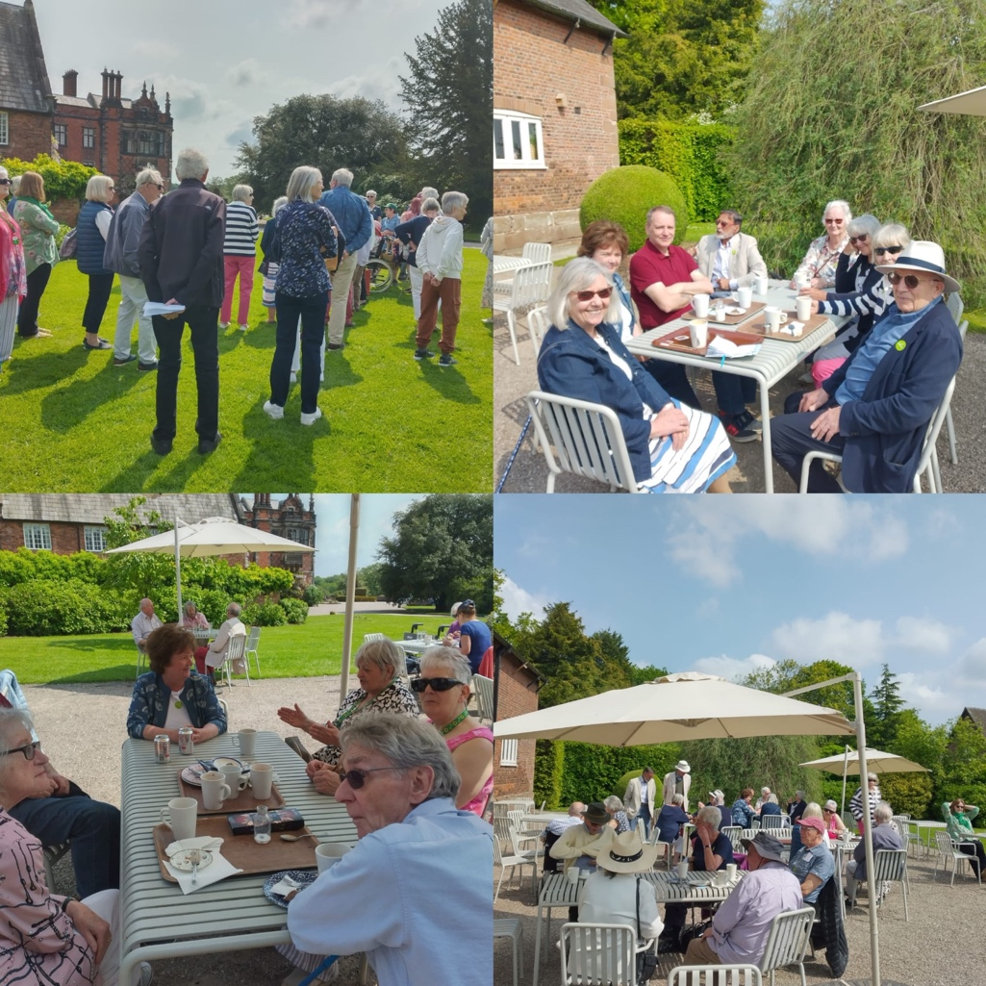
Parkinson's UK is here to provide information and support to anyone affected by the condition.

Our helpline is a free, confidential service. Trained Advisers, including Parkinson's Nurse Advisers, Benefit and Employment Advisers and a Care Adviser, provide information about all aspects of living with the condition, including:
- medical issues, including symptoms and treatments
- emotional support
- health and social care
- local activities
- employment and benefits
- signposting to other sources of information
Helpline Advisers can put you in touch with a Parkinson's Adviser in your local area if more local or in depth information and support is needed.

Parkinson's Local Advisers have a wide range of knowledge and expertise about Parkinson’s and can help if someone:
- has been newly diagnosed and is looking for advice and information
- is looking for tips on how to deal with the day to day impact of Parkinson's
- would like to find out about services in their local area, including health services, such as Parkinson's Nurse Specialists and Physiotherapy and how to access them
- has a friend or family member who needs support
- needs emotional support
- wants to learn about their rights and entitlements
- needs help navigating the benefits process
- needs support with anything else relating to life with Parkinson's
The free helpline is open:
Monday to Friday - 9 am-6pm
Saturday - 10 am-2 pm
Please call: 0808 800 0303

Parkinson’s UK – Chester & District Branch

Singing group/choir

St Columba’s Church Hall, Plas Newton Lane, Chester CH2 1PL

Fridays 1pm – 2.30pm

Excellent parking, good access and facilities

Come along, sing your much-loved favourites and learn some new songs too.

EVERYONE WELCOME (with or without Parkinson’s) BRING A FRIEND

Tea, coffee & biscuits - No charge, donations asked for refreshments.

-------------------------------------------------------------------------------------
Our successful Group continues to grow and is much appreciated by all. It is fun and social as well as being excellent vocal therapy.

On 29th September we held an afternoon of “September Songs” with afternoon tea for our families, friends and Branch members. A lovely time was had by all. It was wonderful to show others that you don’t need to have a great voice or be able to read music in order to enjoy getting together and singing. Why not join us? Photos of the day:
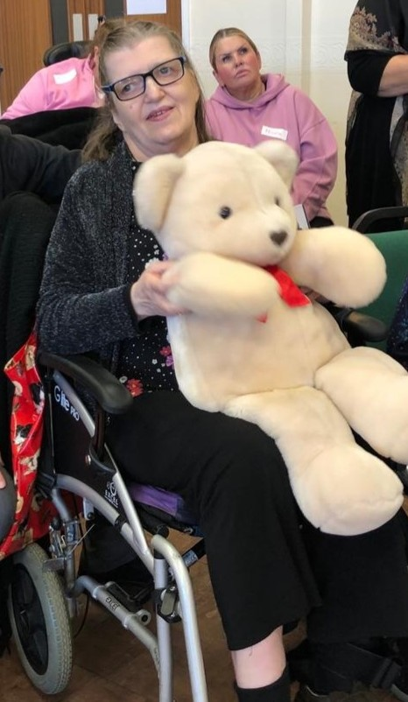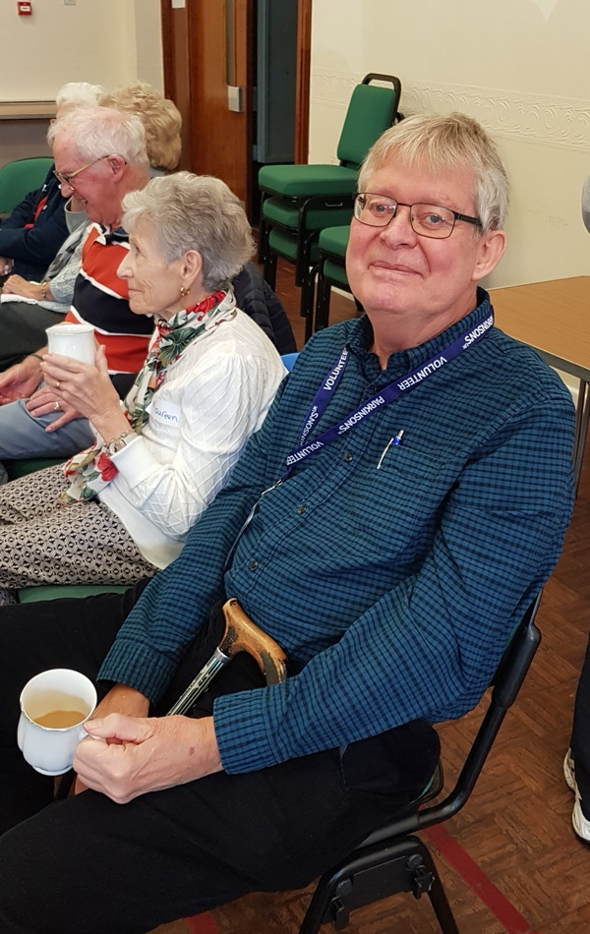
Peggy loved her raffle win - Our Chairman, Nick, said it was a "wonderful afternoon" and thanked all involved
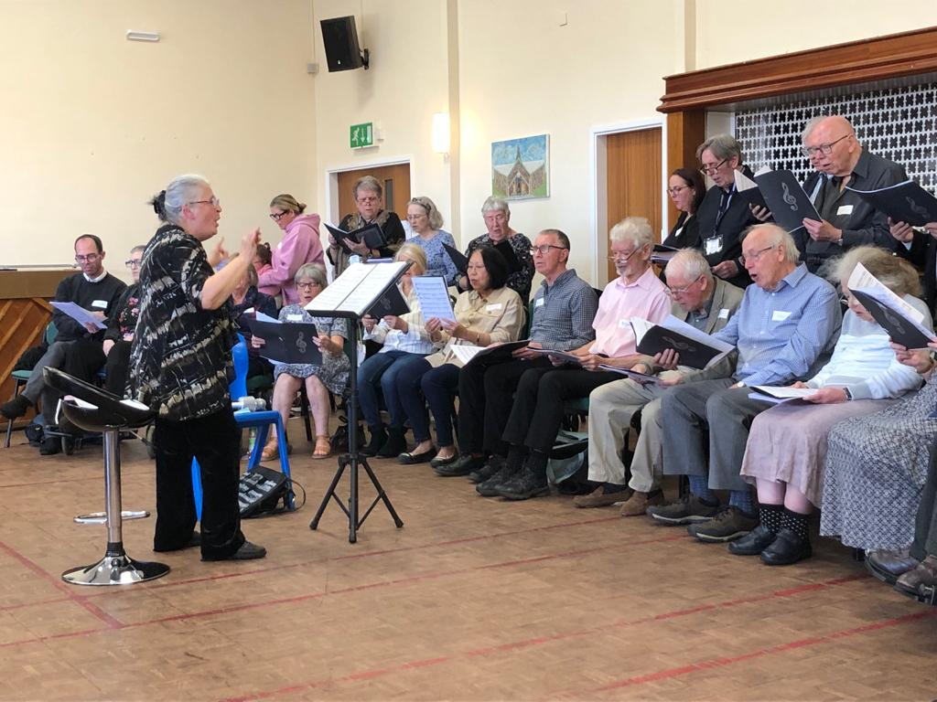
Warming up
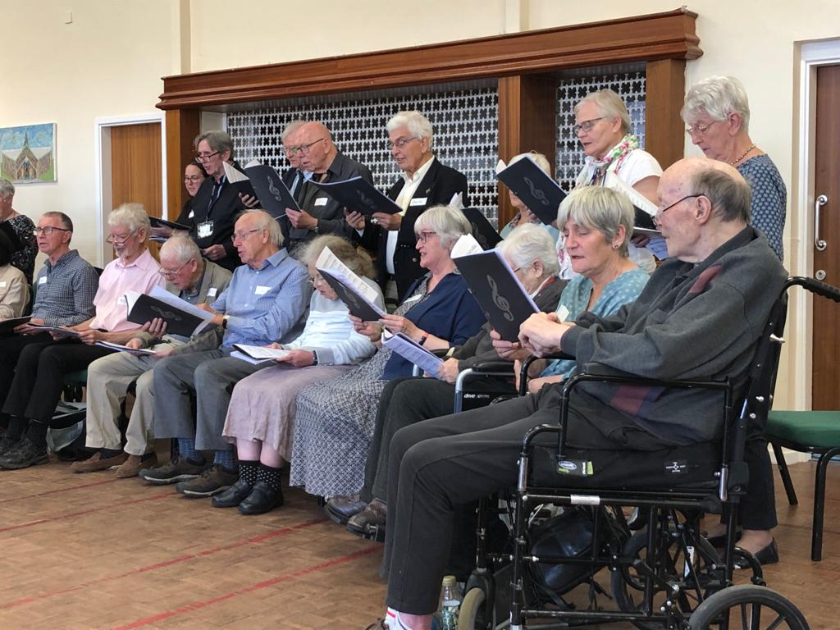
Looking smart
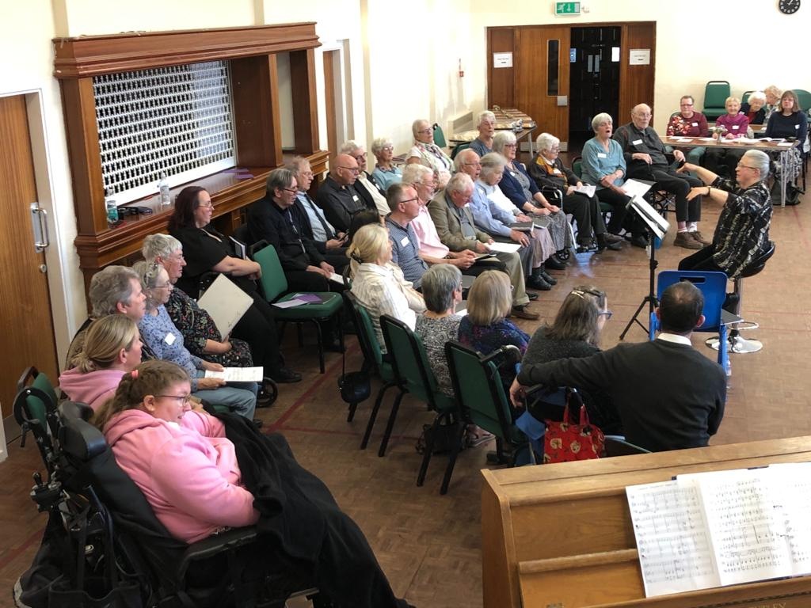
The whole ensemble clearly concentrating!
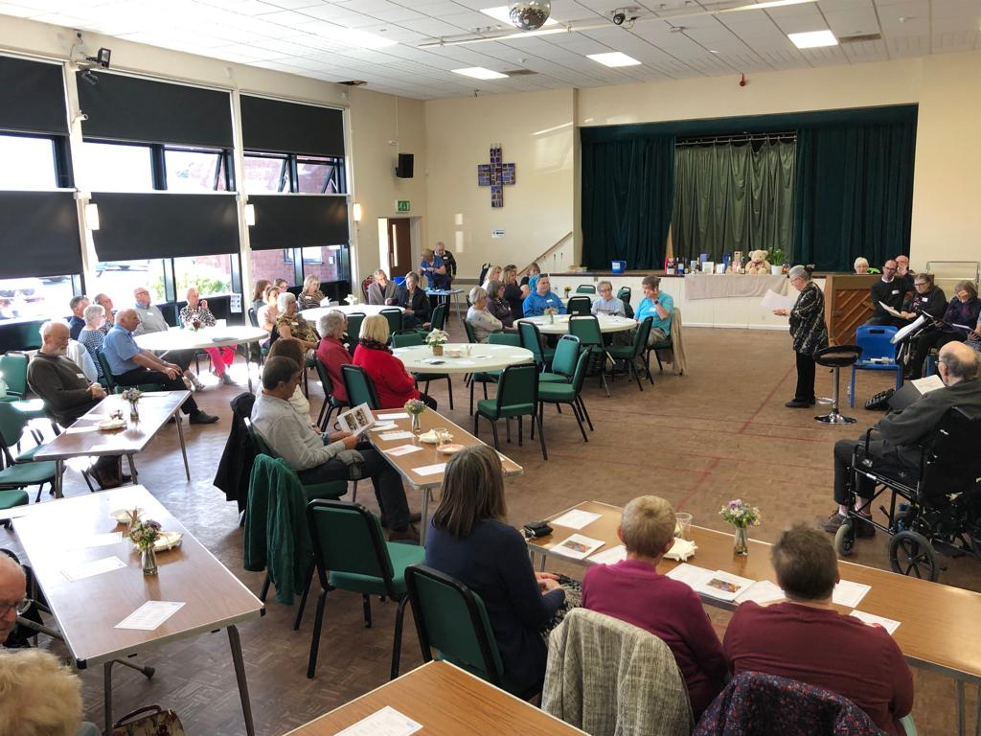
An appreciative audience taking their seats
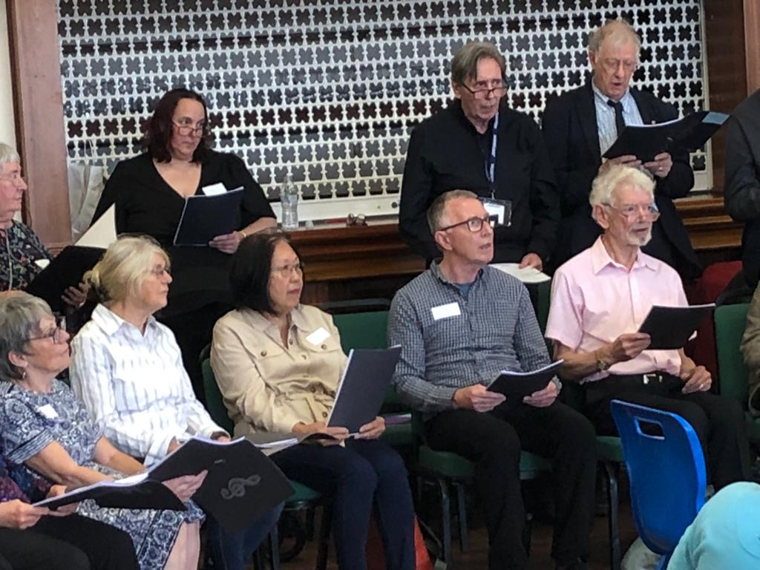
Paying close attention to our Conductor, Brenda
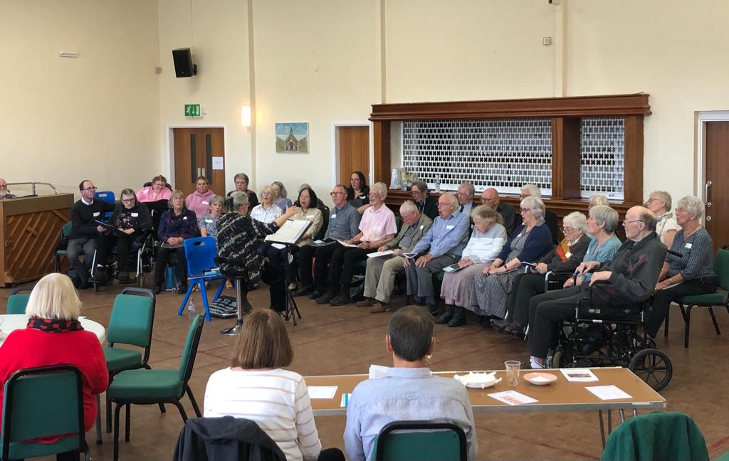
St Columba's Hall is perfect for our needs
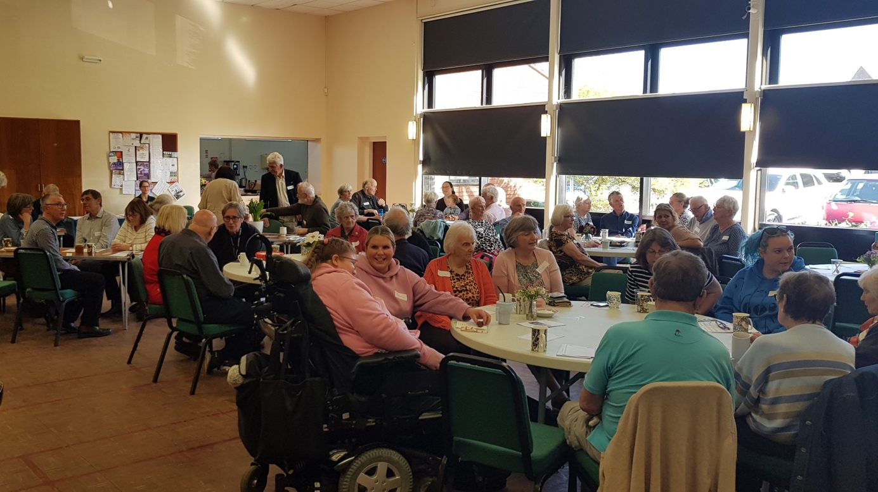

The audience look happier when the wonderful afternoon tea arrives

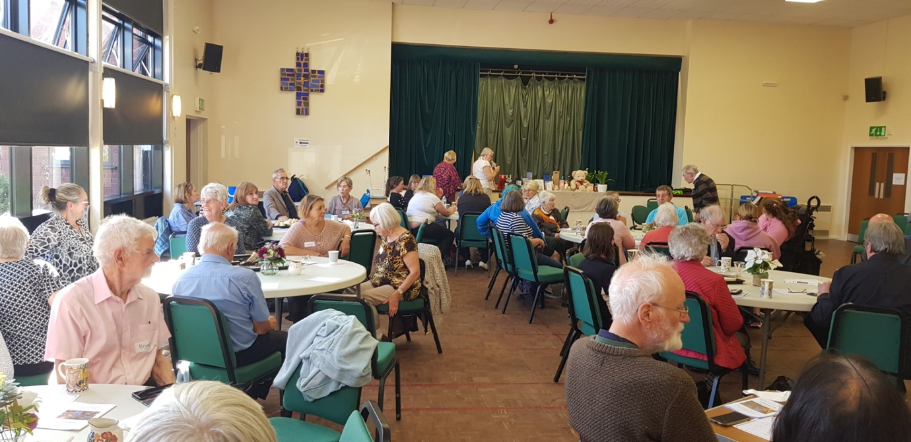

So many raffle prizes donated, Pam and Caroline have it sorted!

Parkinson’s UK
Chester & District Branch
Christmas Lunch
Friday 15th December 2023 arrival from 11.45am
Rowton Hall Hotel, Whitchurch Road, Chester CH3 6AD

BOOKING IS ESSENTIAL – closing date 24th November
When reserving your place, state guest names, menus choices and any dietary requirements. Payment will be required by 1st December

Contact Pam: paminchester@yahoo.co.uk Tel: 01244 376546

MENU
2 COURSES, MAIN & DESSERT, £23 PER PERSON
Roast Turkey Breast, Roast Potatoes, Apricot Stuffing, Seasonal Vegetables,
Pigs in Blankets, Red Wine Gravy (gf*)
Sea Bass Fillet, Crushed New Potatoes, Seasonal Vegetables, Dill Butter Sauce (gf)
Mixed Herb & Nut Roast, Roast Potatoes, Seasonal Vegetables, Veg Gravy (gf)(v)(ve)

~oOo~

Christmas Pudding, Brandy Sauce, Spiced Maple Butter, Cranberry Compote (ve*) (v)
Baileys & White Chocolate Cheesecake, Raspberry Coulis & Vanilla Chantilly
Lemon Posset Winter Berry Compote (v)(gf)

~oOo~

Tea/Coffee Mince Pies

Christmas Raffle – Donations for prizes welcome

Walk for Parkinson’s Marbury, Sunday 10th September.
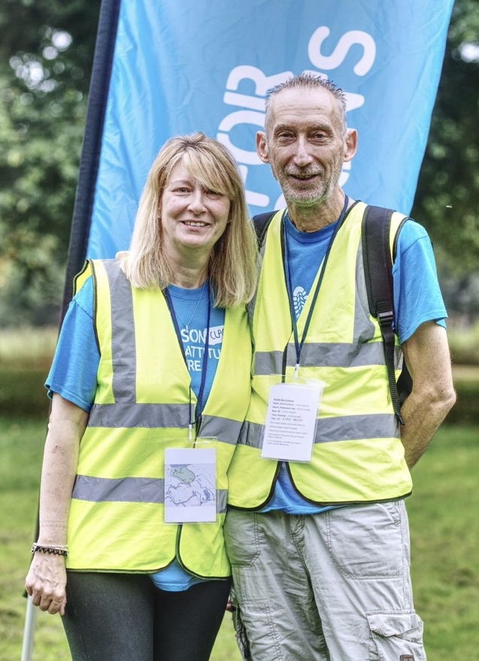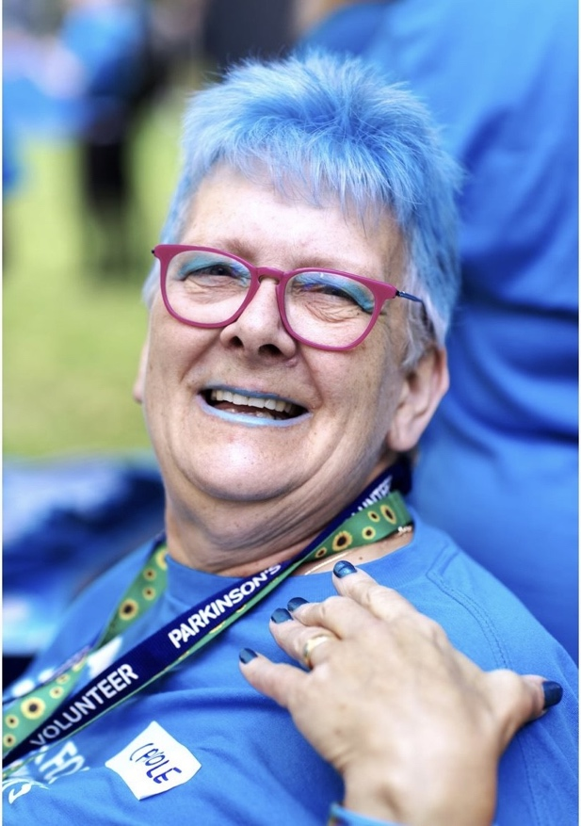
The editor and wife Clare. Carole Buckingham (Crewe Branch)
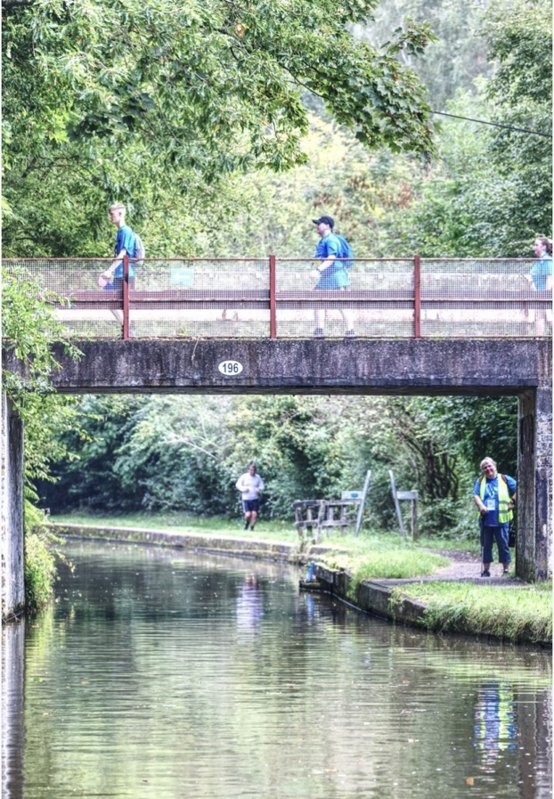
MP for Tatton and Matt Eagles.
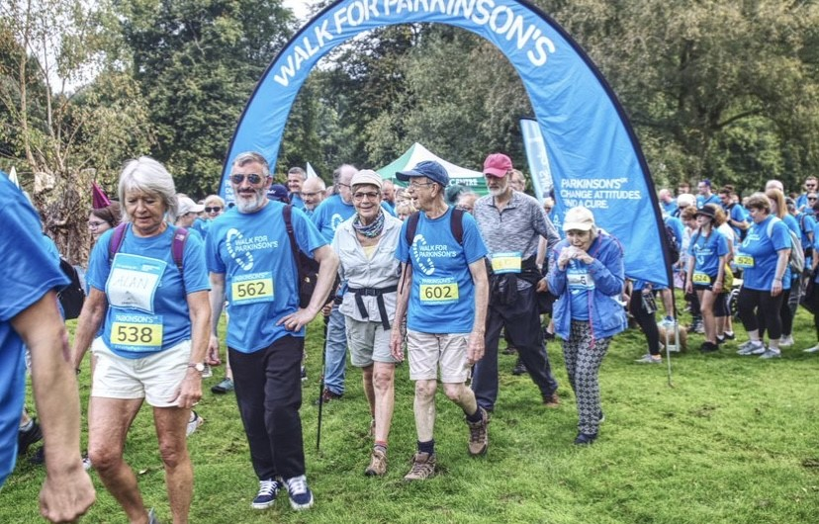
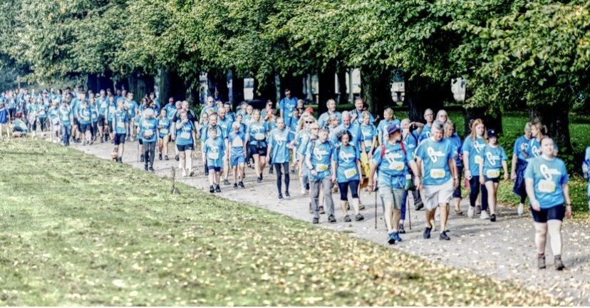
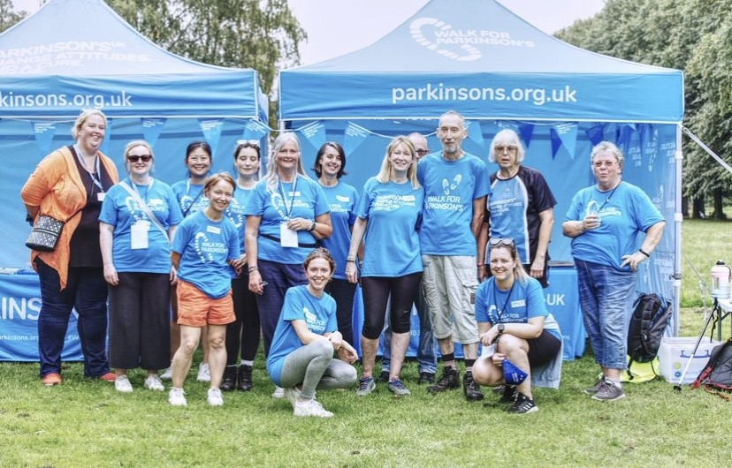
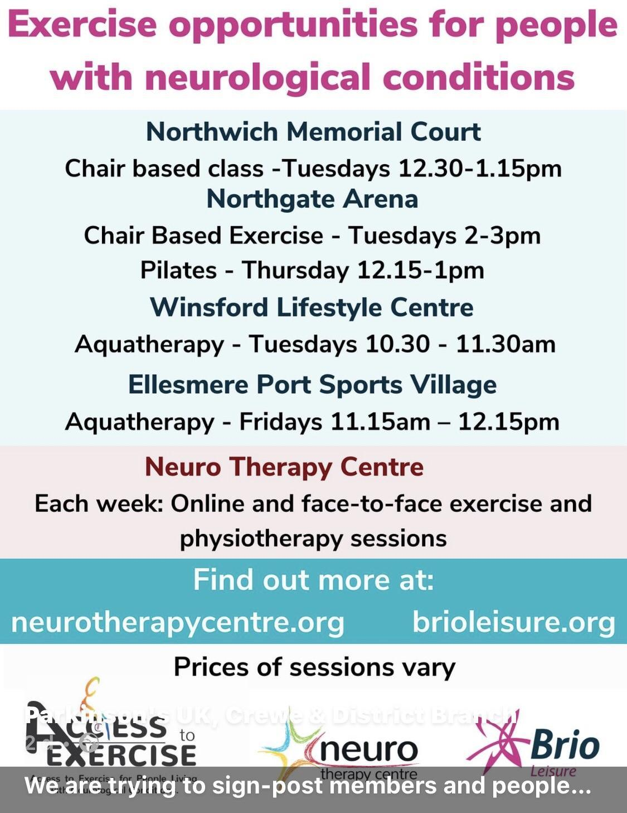

Neurotherapy Centre Saltney, Units C1- C4. Brymau Estate 1, River Lane, Saltney, Chester CH4 8RG
The Neuro Therapy Centre is growing
The Neuro Therapy Centre is planning to expand its physiotherapy, exercise services and counselling support. This will increase the number of people it can support, the options available to access services and the days/times they are available.
They have secured the lease of a building next to the current Centre to create a new home for their physiotherapy and exercise services. This will create a gym that is three times the size of their current space, with a wider range of equipment including some to help those who are looking for a more intense fitness experience. The aim is to have this open by summer 2024.
The second phase of their plans will enable their café and social space to expand as well as increase their counselling and support group services by summer 2025.
Let them know what would help you
The Centre would love to hear your feedback, please take a couple of minutes to complete their survey about the services and support which would help you. Even if you don't use the Centre currently it would still be really helpful for them to hear your views.
The Survey is available at: https://forms.gle/MFg4p6mv2t4nxvEZ7
Physical and Emotional Support Locally
An Access to Exercise & Wellbeing programme is being led by the team at Neuro Therapy Centre, alongside partners Greenbank Sports Academy in Liverpool, Brio Leisure across Cheshire, and The Walton Centre.
As part of the programme the following services are available:
Neuro Therapy Centre
- Physiotherapy
- Accessible gym
- Counselling & support groups
- FES Cycle
- Face-to-face and online exercise classes
Brio Leisure classes
Northgate Arena, Chester
Neuro Gentle Circuit – Thursdays, 2.15pm
Northwich Memorial Court
Chair-based class - Tuesdays, 12.30pm
Winsford Lifestyle Centre

__________________________________________________________________________________

Parkinson’s UK have information about exercise, please see the link to the exercise hub below

https://www.parkinsons.org.uk/professionals/exercise-hub

________________________________________________________

Donations.

The branch always welcomes donations or even more appreciated would be a regular standing order donation...if anyone would like to make a donation whether it be regular or one off please get in touch with Ron Welsh, our treasurer, who will supply the bank information for you to arrange the donation/standing order. You can also contact any of the committee.

An Introduction to Healthwatch Cheshire West
Healthwatch Cheshire West is the local independent consumer champion for health and care services, forming part of the national network of local Healthwatch across England.

Our role is to make sure that those who run health and care services understand and act on what really matters to local people. We engage directly with a wide range of people in community settings, having conversations to help understand issues that are affecting them, gathering feedback and signposting to services, organisations or groups that can help.

We’d love to hear from you.

We want to hear about your views, needs and experiences to help shape and improve local services in the future.

You can share your views with us by visiting the online Feedback Centre on our website: www.healthwatchcwac.org.uk, email: info@healthwatchcheshire.org.uk or telephone : 0300 323 0006, Community Engagement & Project Officer, Tricia Cooper.

Members of the team often visit local community groups so keep your eyes out for us. We look forward to meeting you and hearing your experiences.

BRANCH TEXT MESSAGING SERVICE.

The Branch have a Text Message reminder service sending out reminders of upcoming events to our members free of charge. If you would like to receive this service, then you just need to take a few minutes to register.

Just text your NAME, MOBILE PHONE NUMBER and YES to 07768146835. If you would prefer us to send the text messages to a friend, family member or carer on your behalf then just add FOR and the NAME to your text message request to join. If you believe you have already registered but haven’t been receiving any messages could you, please resubmit your details to the above number and in addition to the requested information just include PROBLEM

—---------------------------------------------------------------------------------------------

Other Contacts

For information and resources from Parkinson's UK visit www.parkinsons.org.uk

For advice, emotional support or to access the Parkinson's Adviser service, contact the Parkinson’s UK Helpline, available Monday to Friday: 9am to 6pm, Saturday: 10am to 2pm on 0808 800 0303 or by emailing hello@parkinsons.org.uk

The Walton Centre Nurse Advice Line is 0151 556 4008

Branch Membership – If you know anyone who has Parkinson’s or is caring for someone with Parkinson’s or would just like to join, please encourage them to get in touch with any of the committee, thanks.

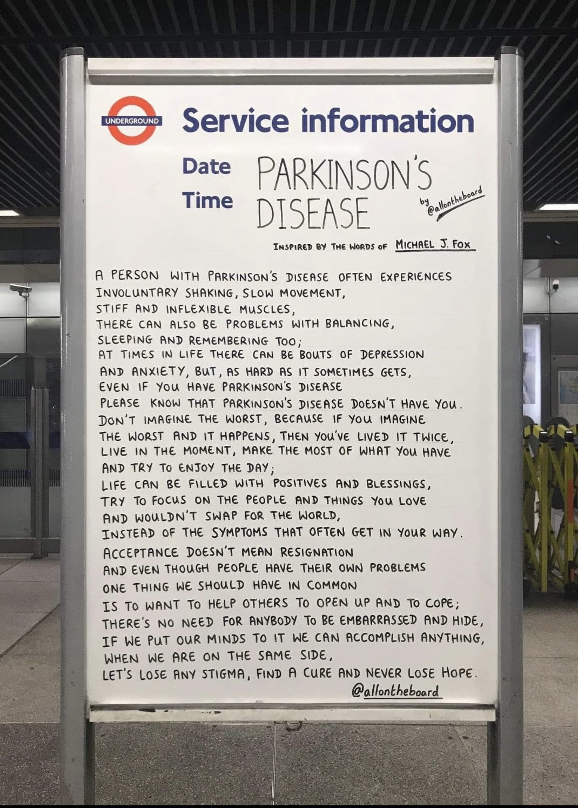

In summary (Events)

Monday 3 - 4pm Choir. on Zoom. Contact Alison Richards 07899 726859 or thecommunitysingingcompany@gmail.com More information in the link below.
https://localsupport.parkinsons.org.uk/activity/online-social-singalong
https://www.facebook.com/search/top?q=the%20community%20singing%20company

Thursday 5pm Pam’s People – Zoom chat every week, contact Pam for joining details. Also see the link below
https://localsupport.parkinsons.org.uk/activity/chester-branch-zoom

3rd Thursday of each month 2.30 -4pm - Drop in Cafe at Hoole United Reformed Church. For Details contact Alistair on 01244 311402

Friday 1 - 2.30pm Therapeutic singing group – Every Friday at St Columba’s, contact Liz for details.

Please see the calendar for further information on future events.

It is essential to book for the above coffee mornings or Lunch
Contact Pam: 01244 376546 or paminchester@yahoo.co.uk

Free IT Support at Home see link below.
https://abilitynet.org.uk/at-home/request-free-it-support-home
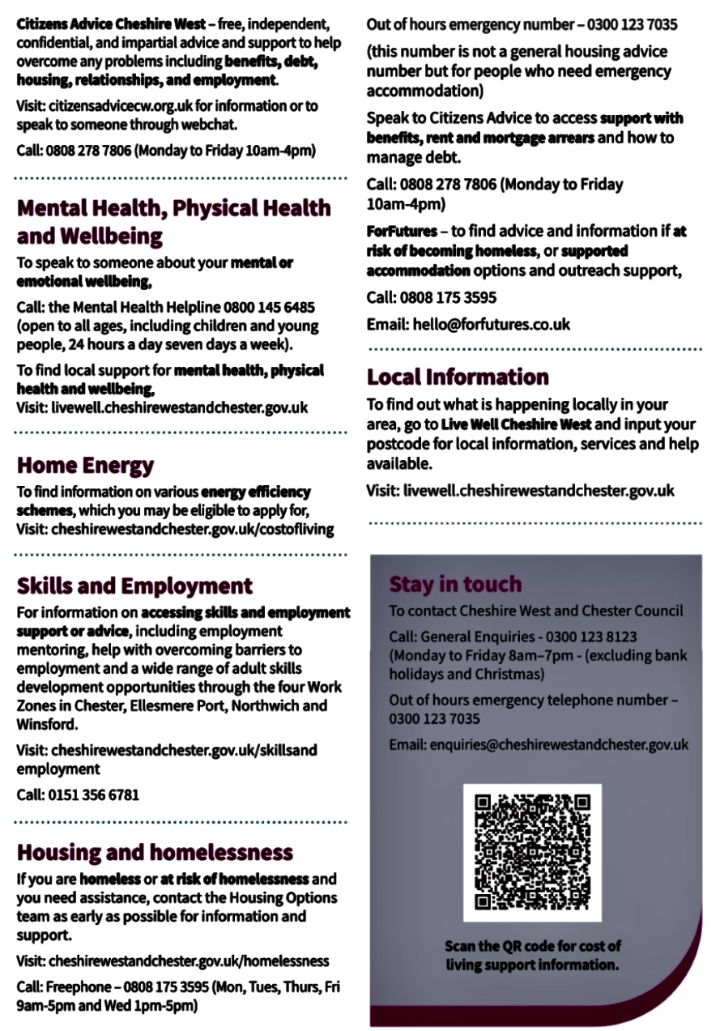
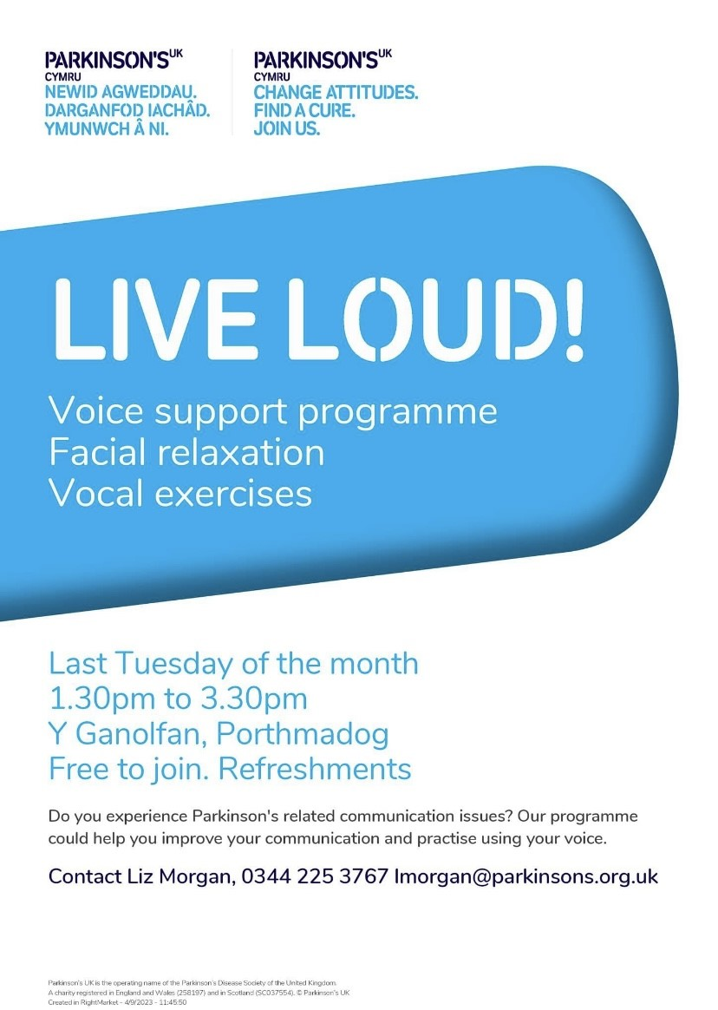

Contacts:

Chairman Vice Chair
Nick Dent Pat Riddell
01244 301378 07941839161
npdent@aol.com patriddell31@aol.com

Secretary Membership
Alistair Tranter Margaret Whaley
01244 311402 mkwhaley3@gmail.com
alistairtranter@btinternet.com

Social Secretary Choir
Pam Adams Liz McClure
01244 376546 01244 409414
paminchester@yahoo.co.uk elizabeth.mcclure070@gmail.com

Treasurer Parkinson’s Post
Ron Welsh Chris Knight
ronwelshco@aol.com chrisknight1@hotmail.co.uk

David Stoddart John Fetherston
david.stoddart3@btinternet.com fetherston132@gmail.com

Alan Needham
alan.needham52@gmail.com

Viscount Michael Ashbrook – President of the branch.

Chester & District Branch Parkinson's UK
c/o The Bluecoat Charity,
The Bluecoat,
Upper Northgate Street,
Chester. CH1 4EE

